**TUGAS 3 (PROJECT AKHIR)**

**LAPORAN TUGAS AKHIR PEMOGRAMAN BERBASIS FRAMEWORk**

Disusun guna memenuhi tugas mata kuliah “Pemograman Berbasis Framwork”

Diampu oleh dosen:

Muhammad Alif Muwafiq Baihaqy., M. Kom.

Link Github*:*

**

Disusun oleh:

Muhammad Nur Afiz (2022150064)

**PROGRAM STUDI TEKNIK INFORMATIKA FAKULTAS TEKNIK DAN ILMU KOMPUTER UNIVERSITAS SAINS AL QUR’AN (UNSIQ)**

**WONOSOBO JAWA TENGAH TAHUN 2024**

# CODE

1. **AdminMiddleware**

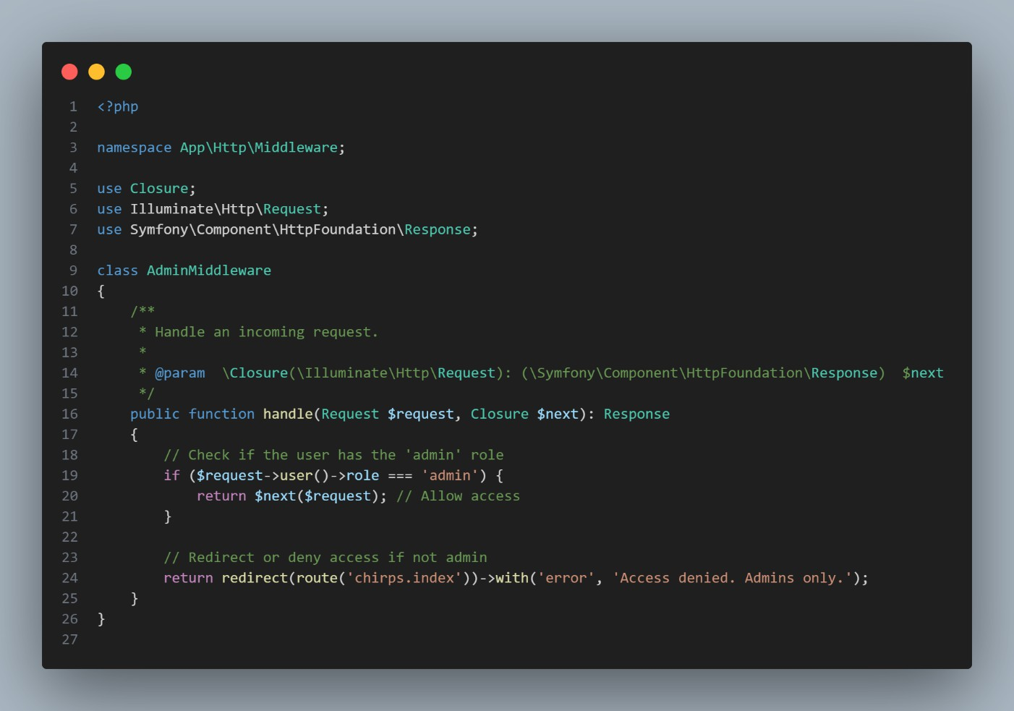

1. **bootstrapApp**

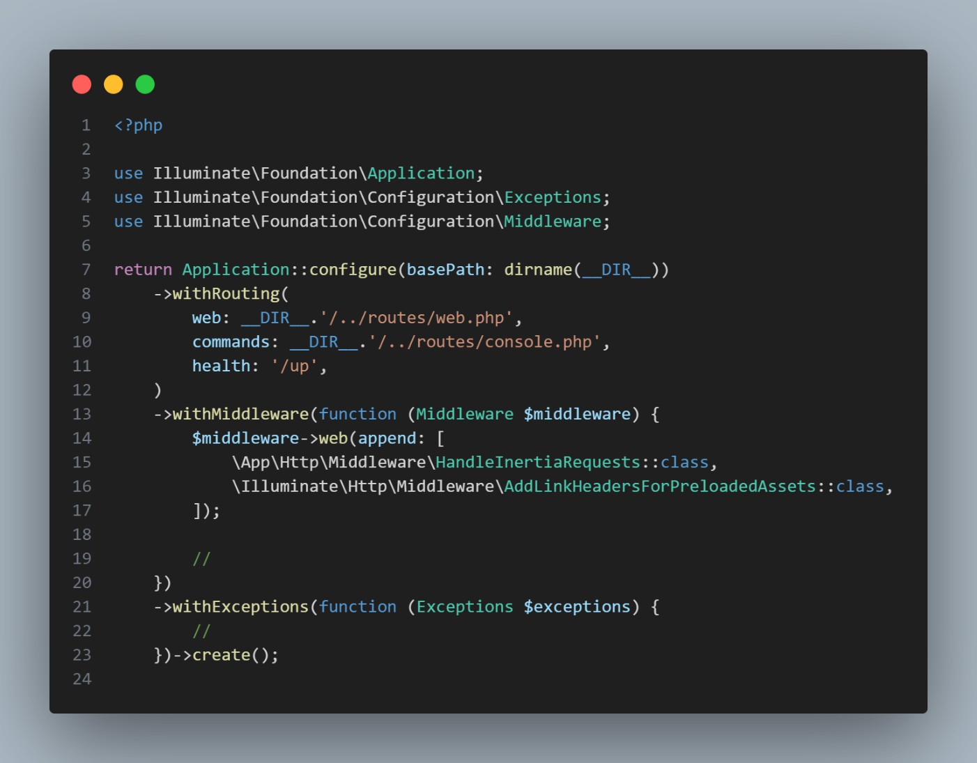

1. **controllerChirper**

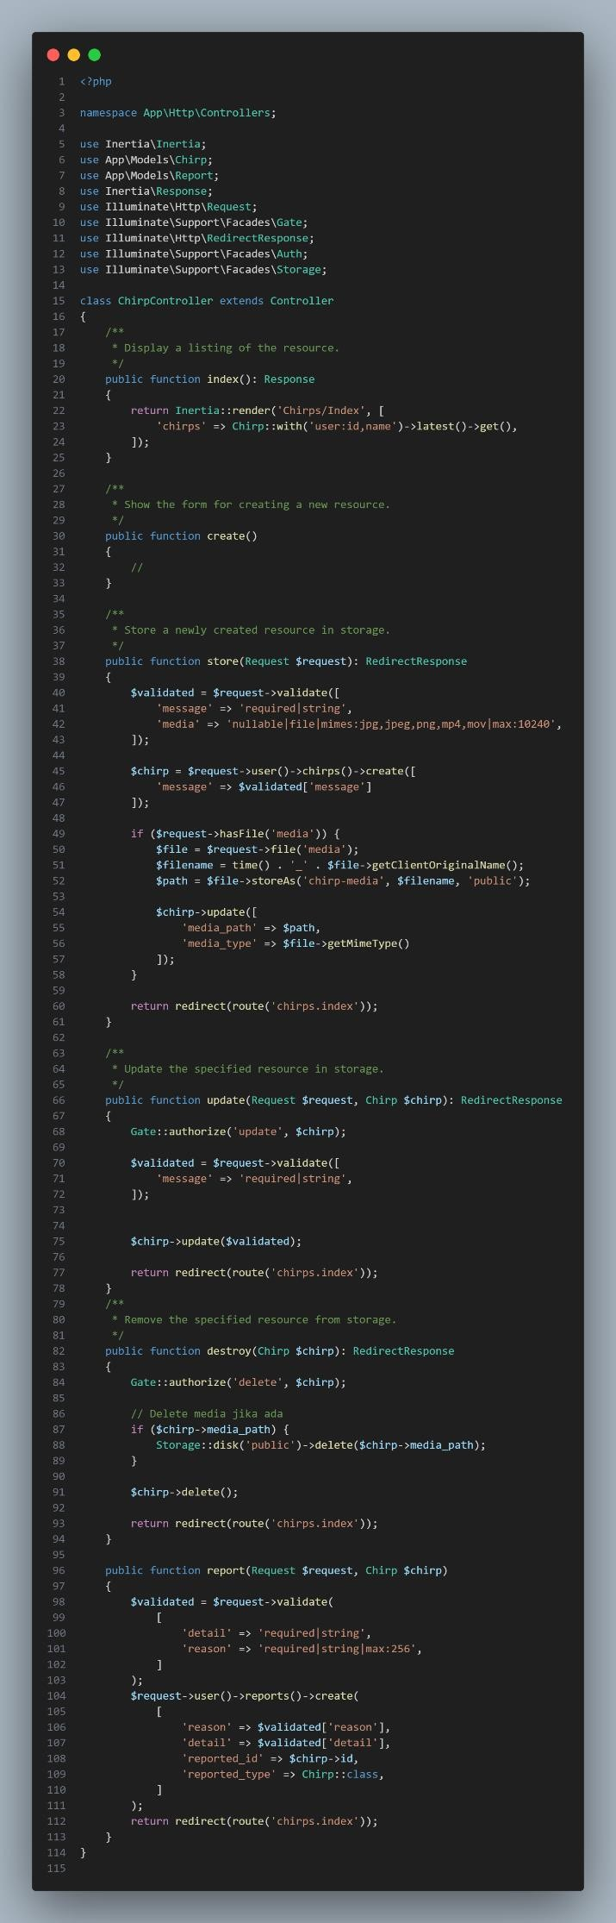

1. **controllerManageChirper**

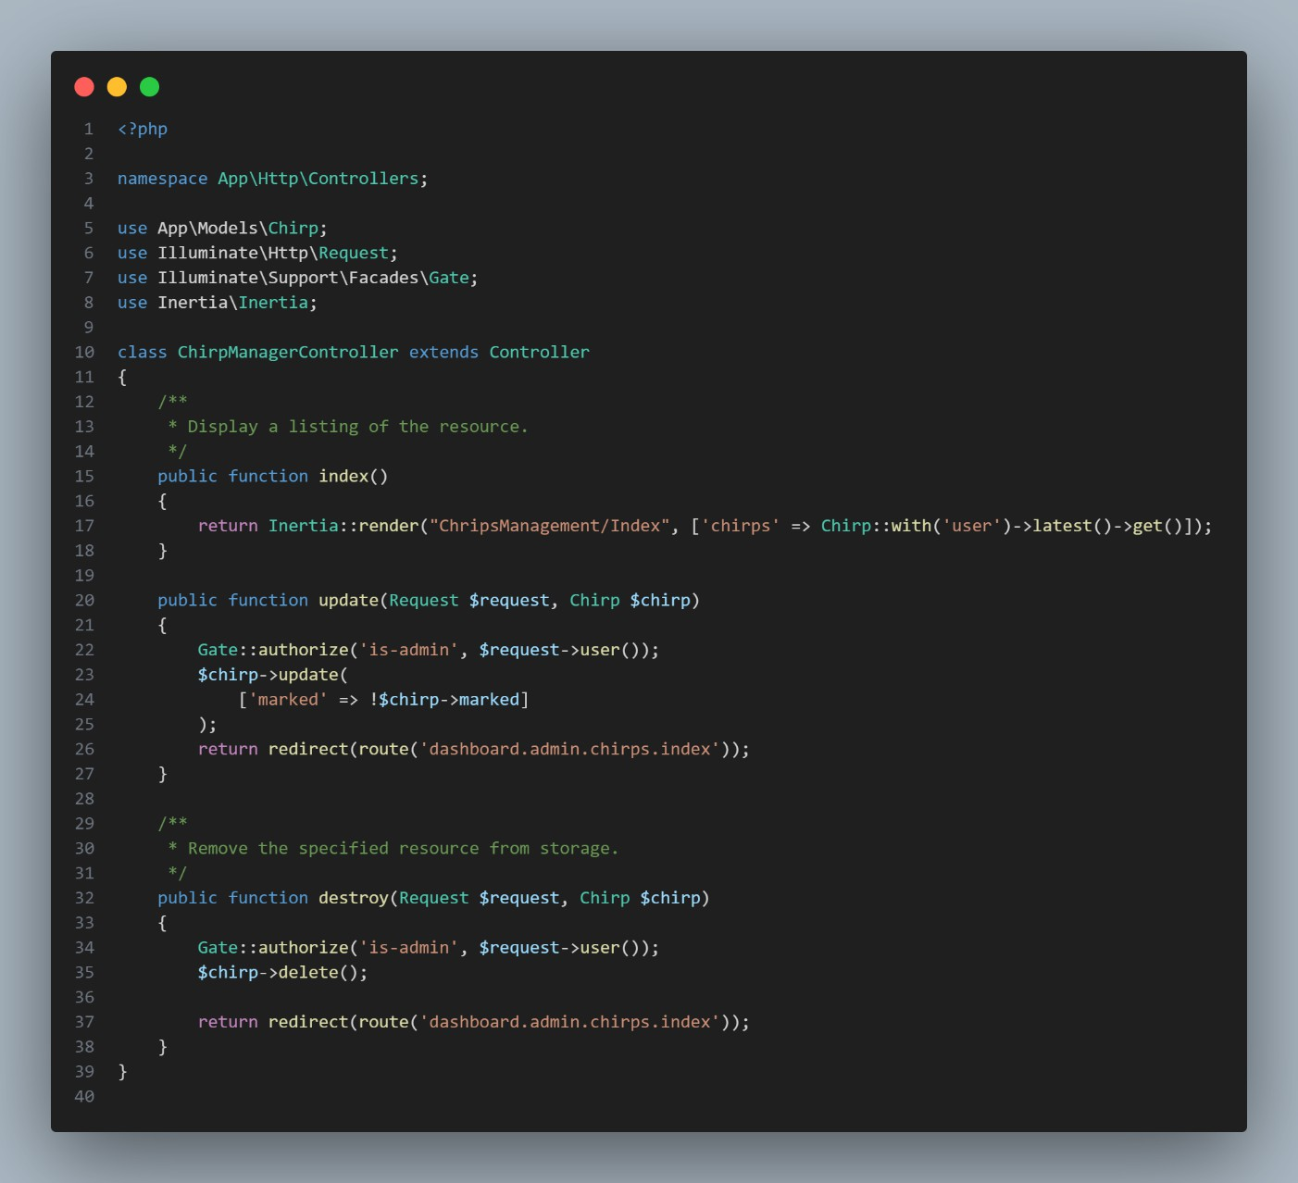

1. **Dashboardcontroller**

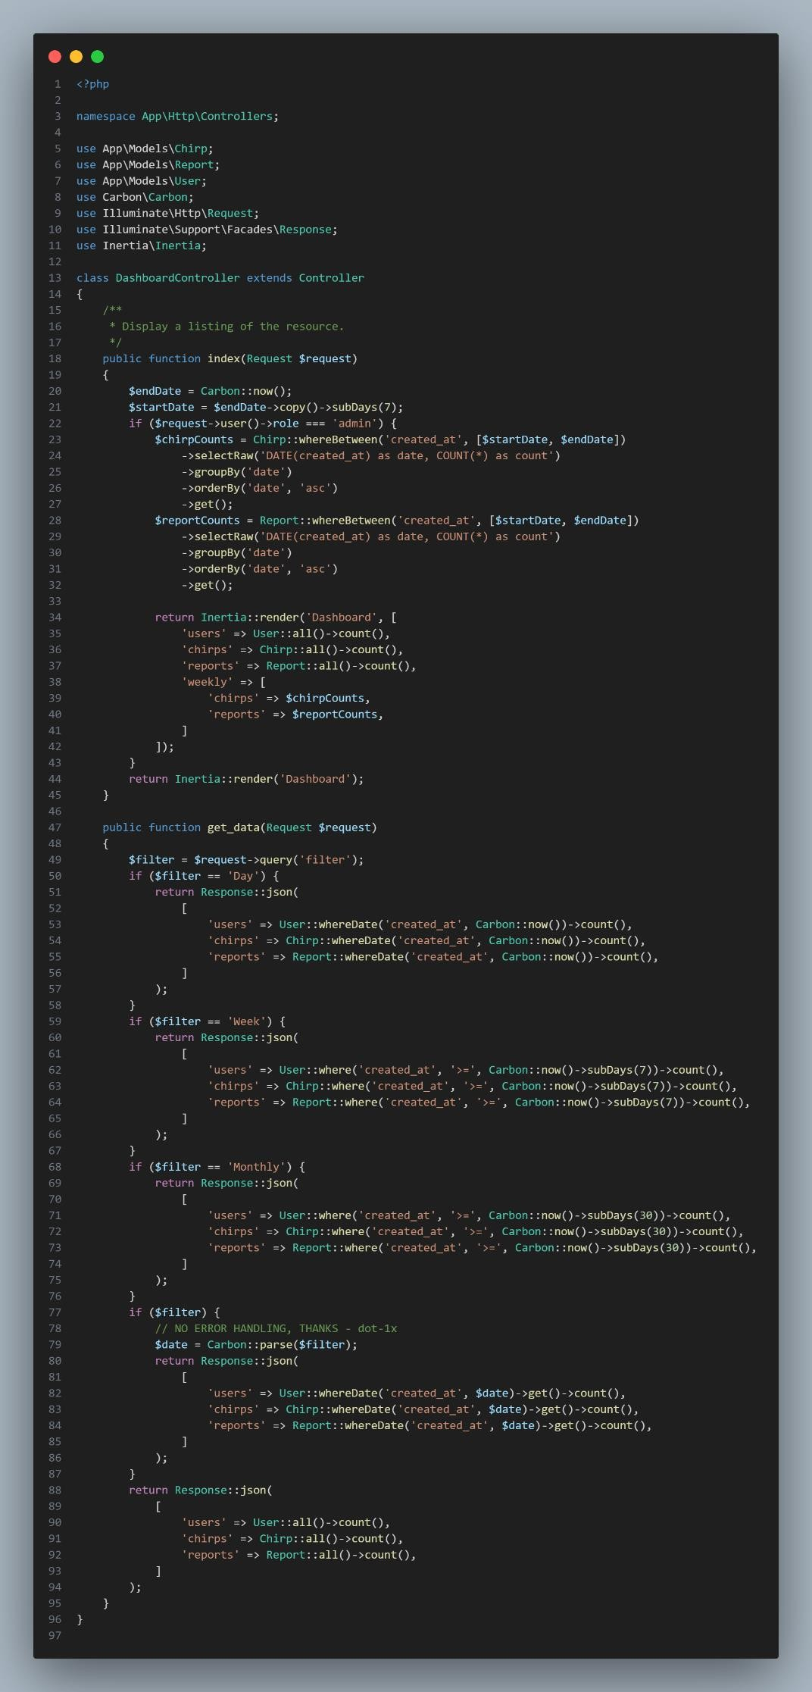

1. 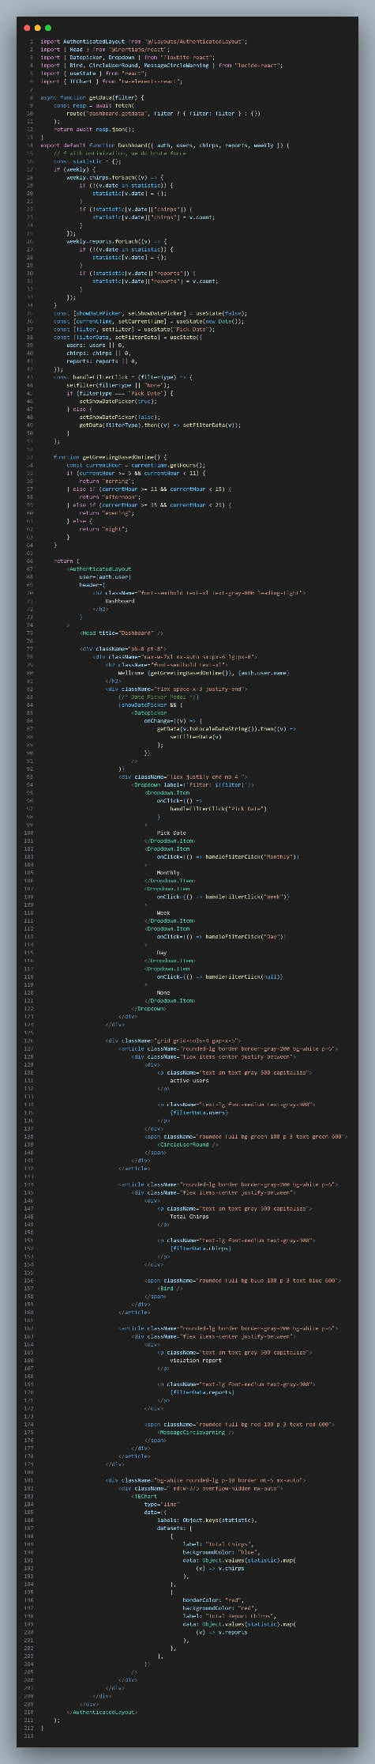**dashboardReact**
2. **Edit ProfileReact**

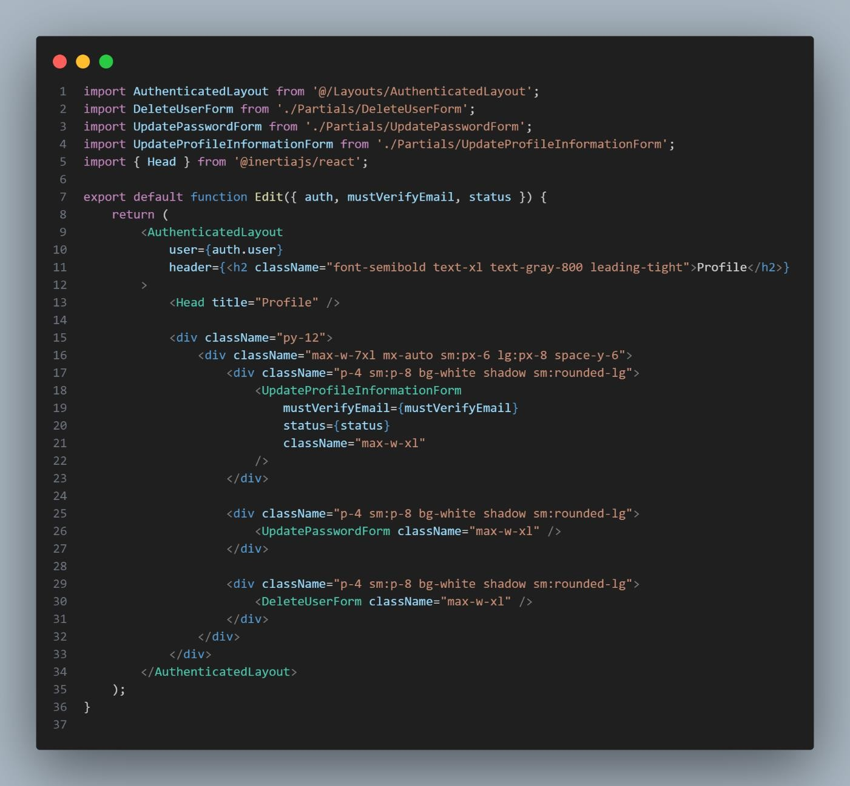

1. **ENV**

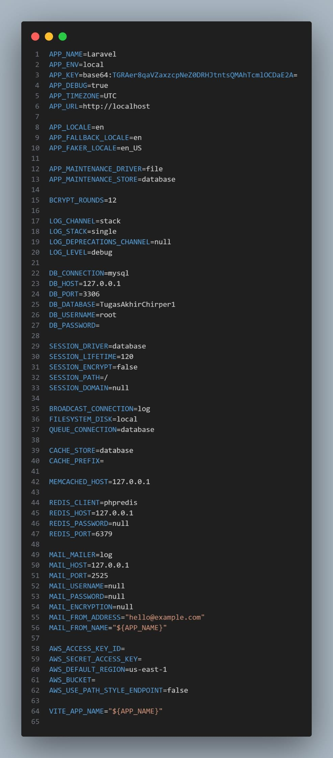

1. **HandleInertiaRequest**

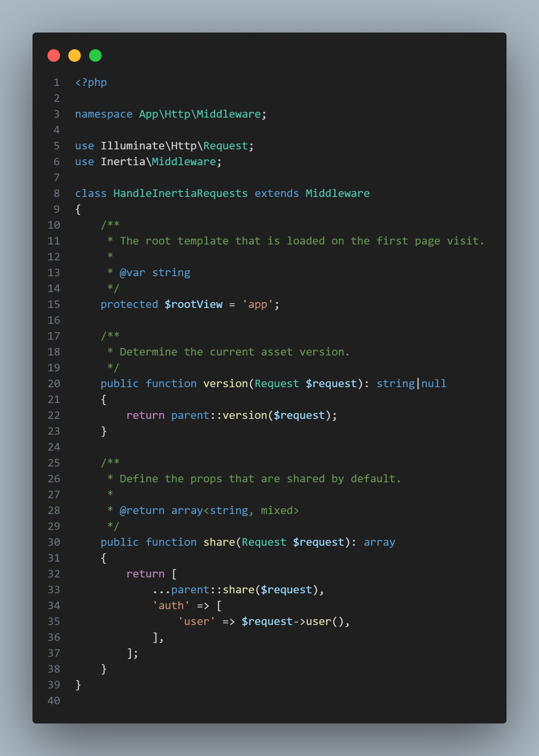

1. **IndexReact**

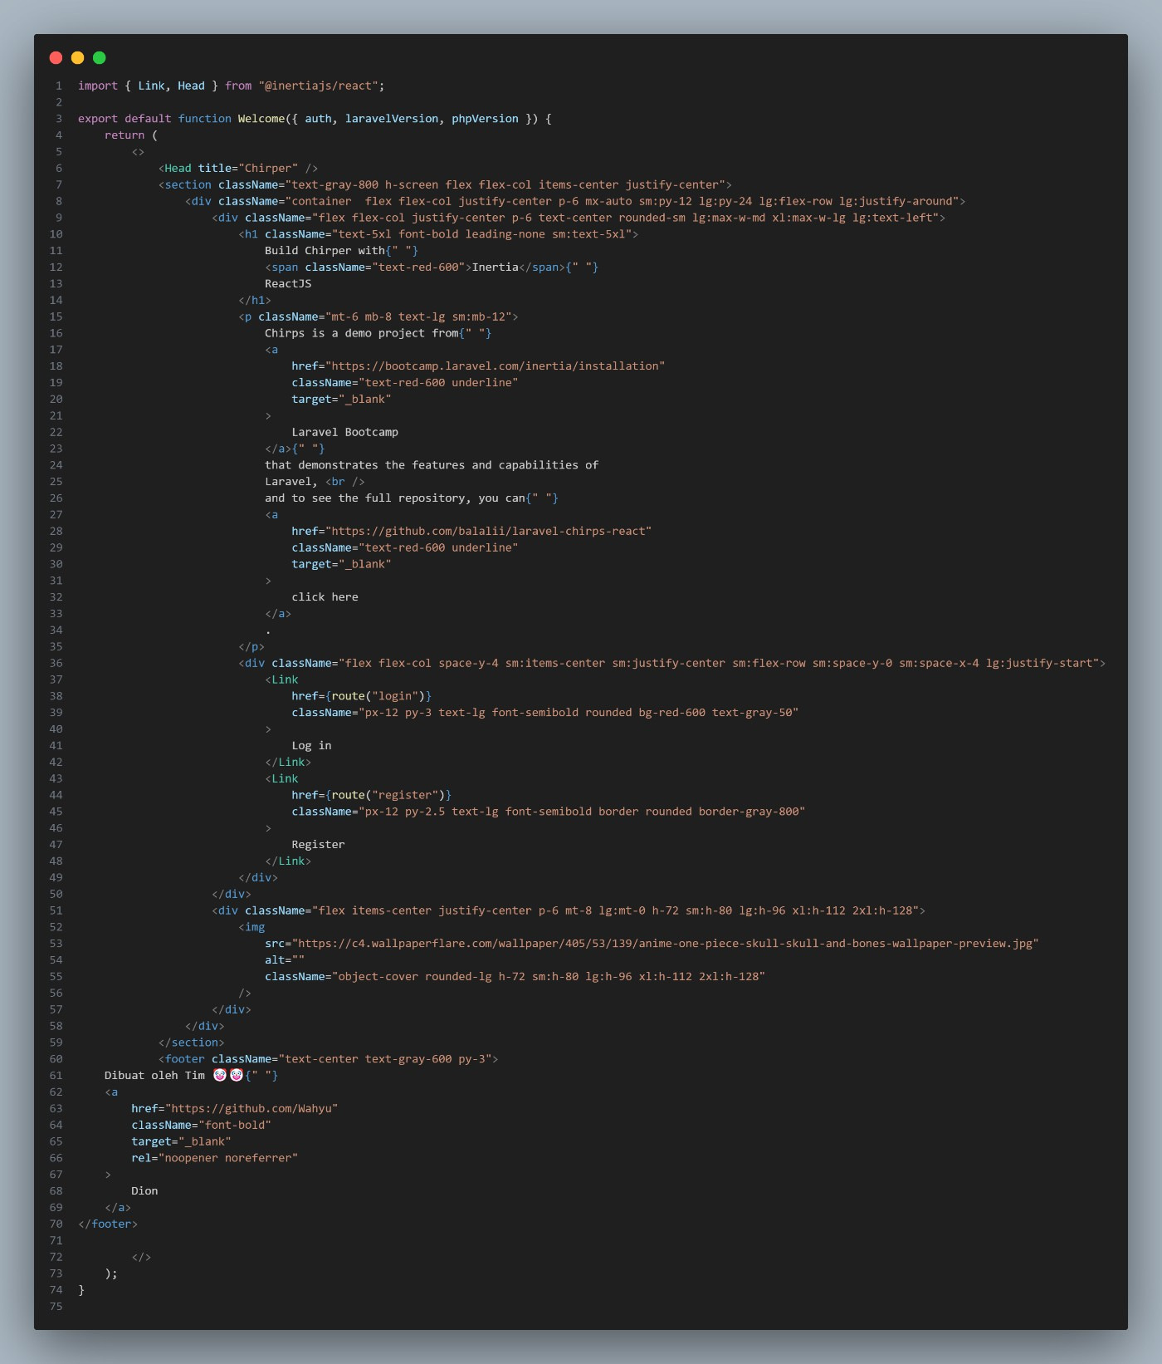

1. **LoginRequest**

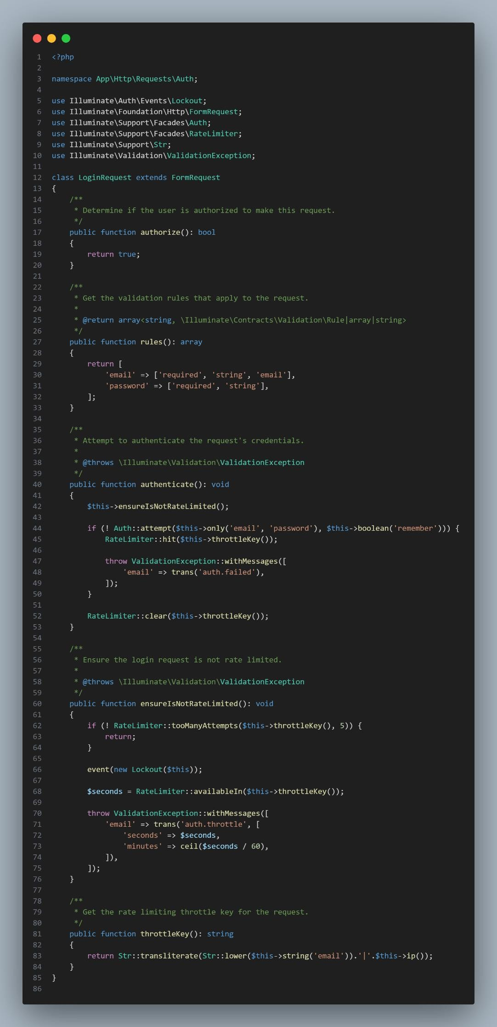

1. **migrationsAddMediaChirps**

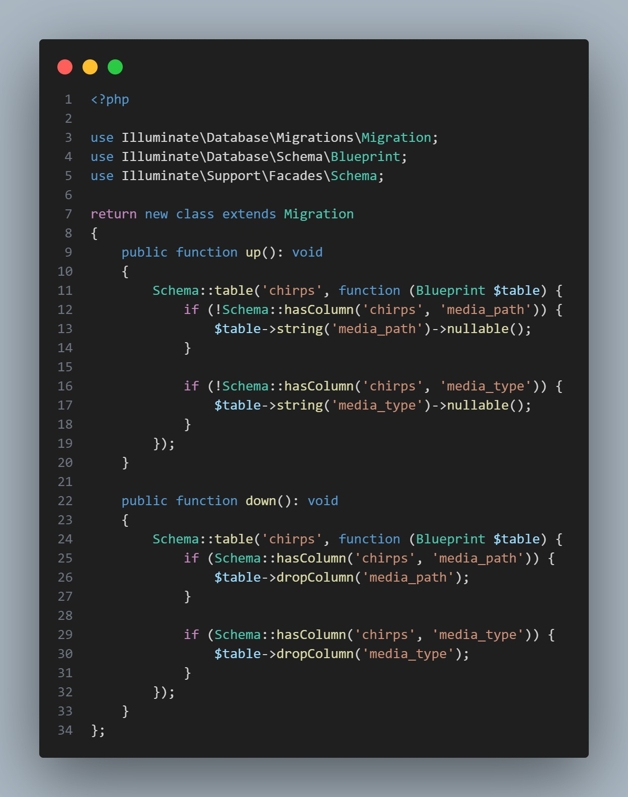

1. **migrationsAddStatusAndRolesToUser**

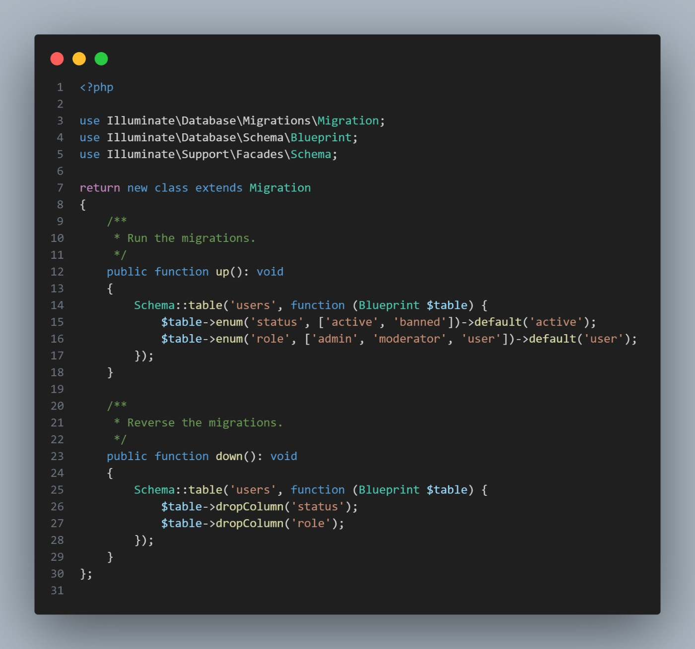

1. **migrationsCreateChirps**

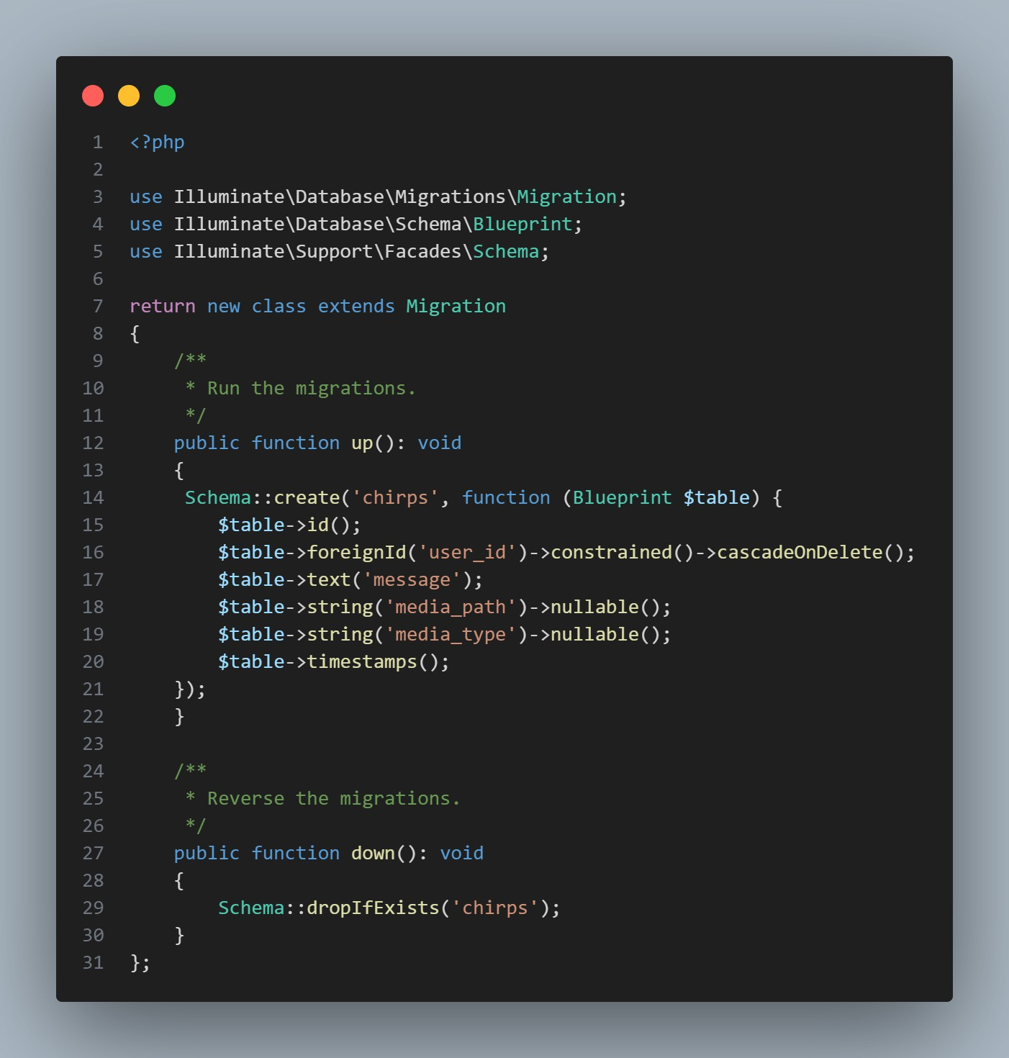

1. **migrationsCreateReportTable**

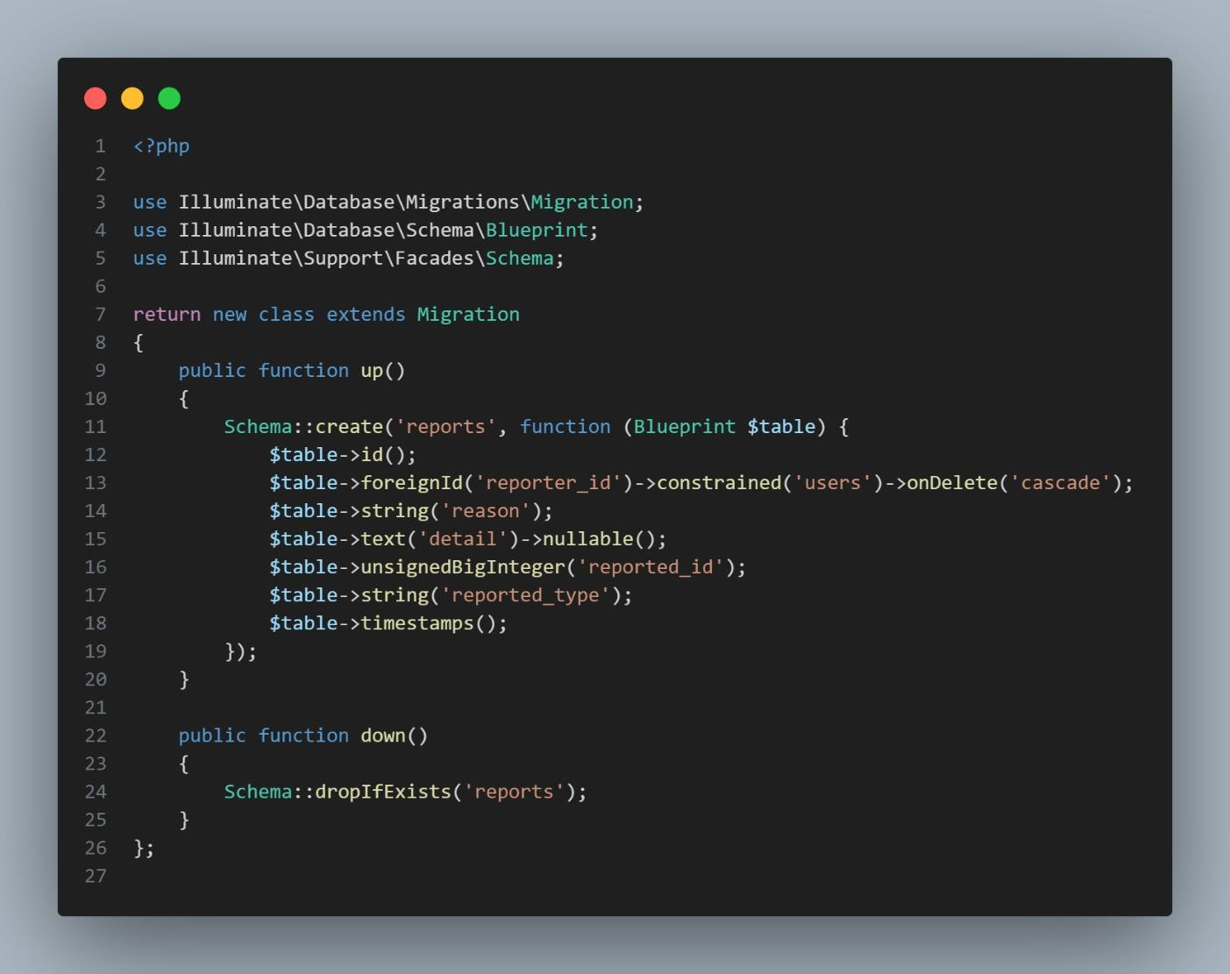

1. **migrationsCreateUser**

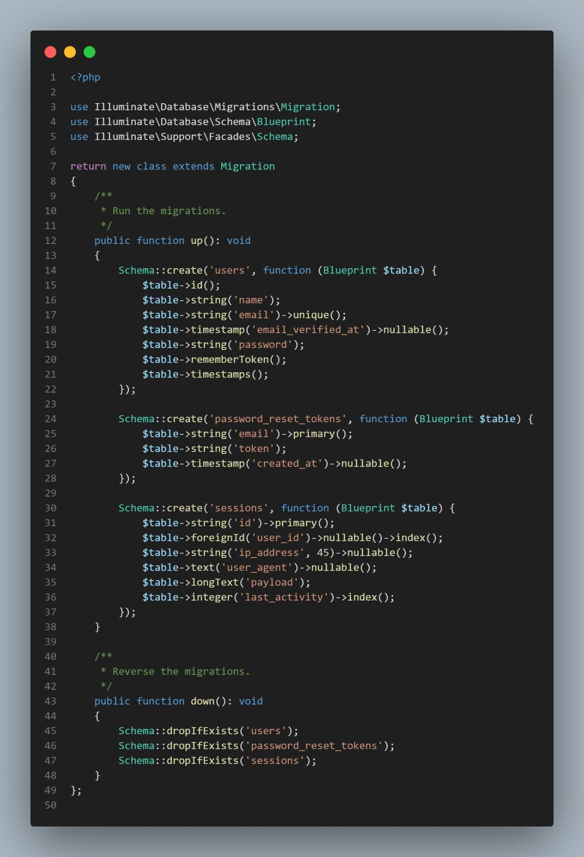

1. **migrationsUpdatePropertyChirps**

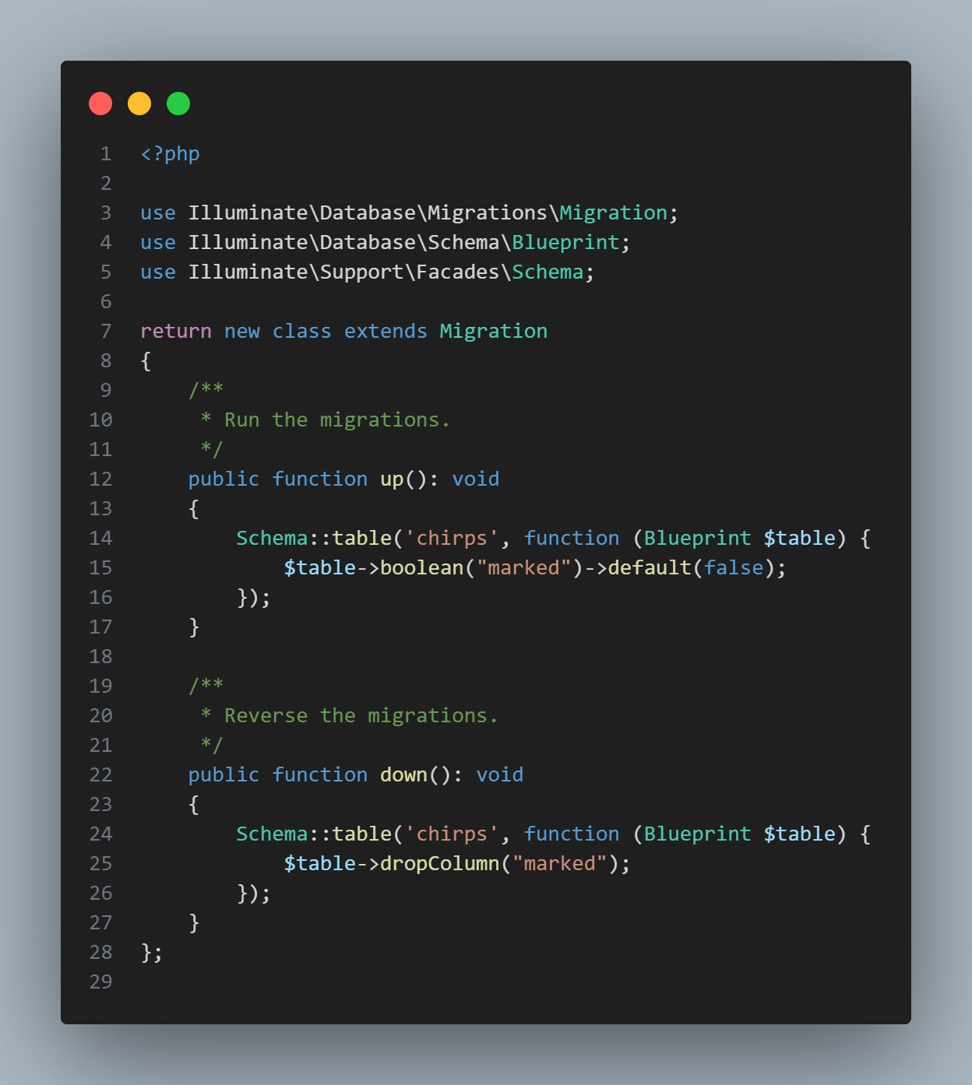

1. **modelChirp**

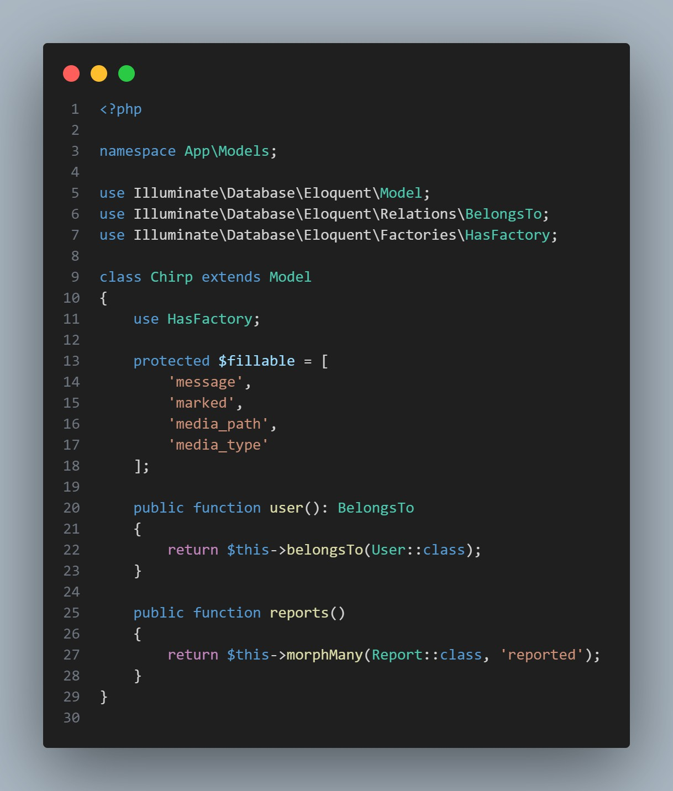

1. **modelReportChirp**

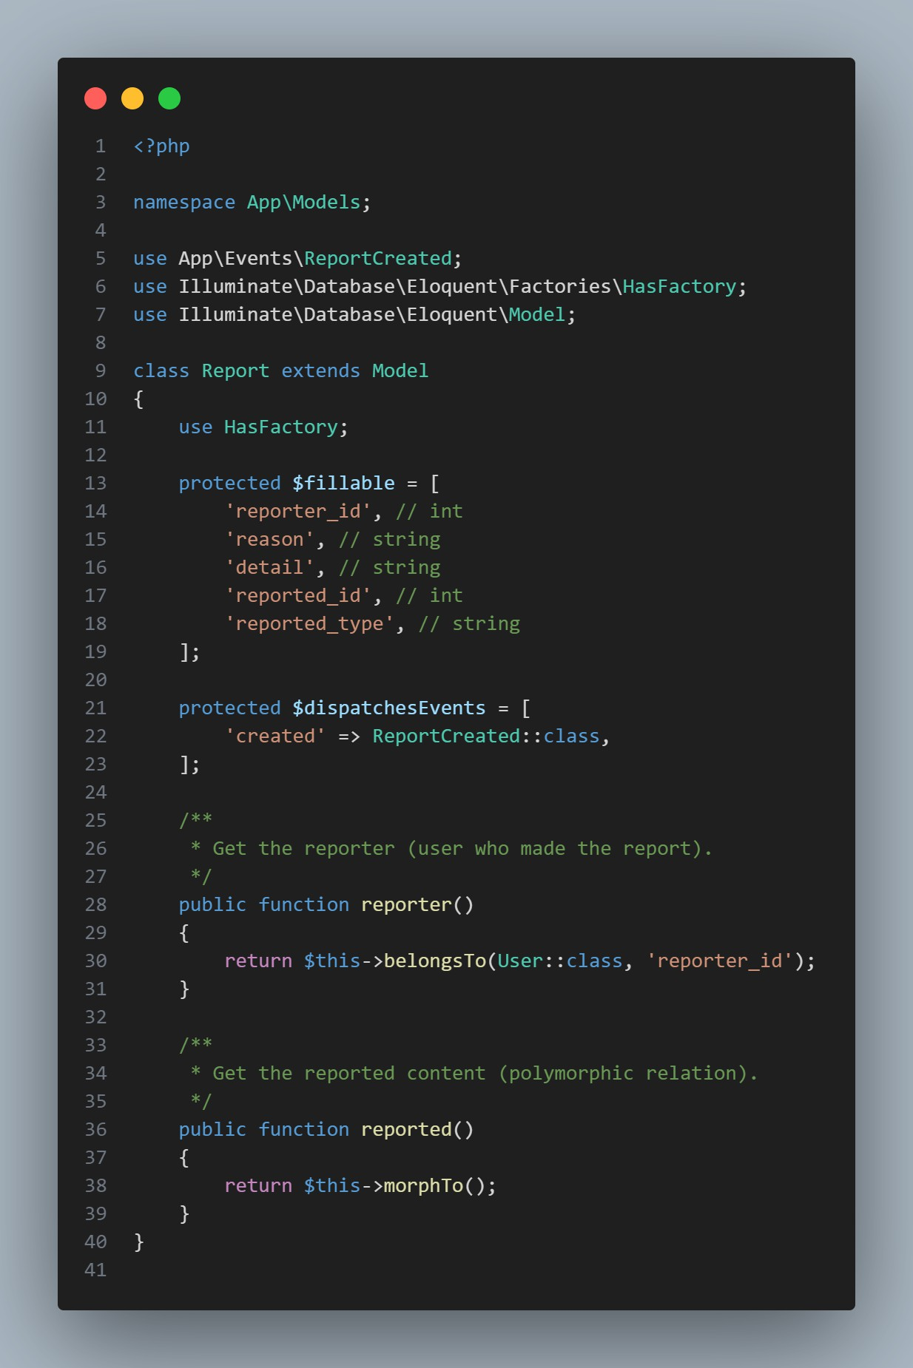

1. **NotificationNewChirp**

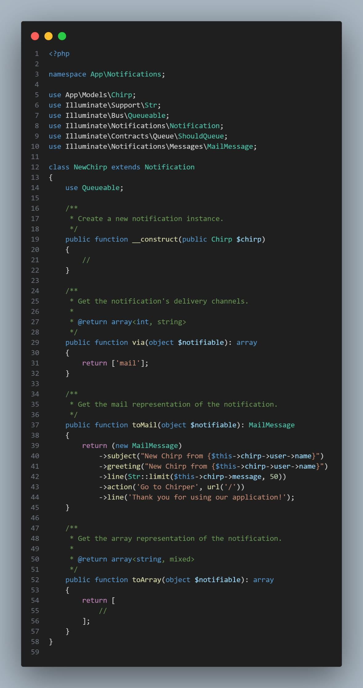

1. **NotificationNewReport**

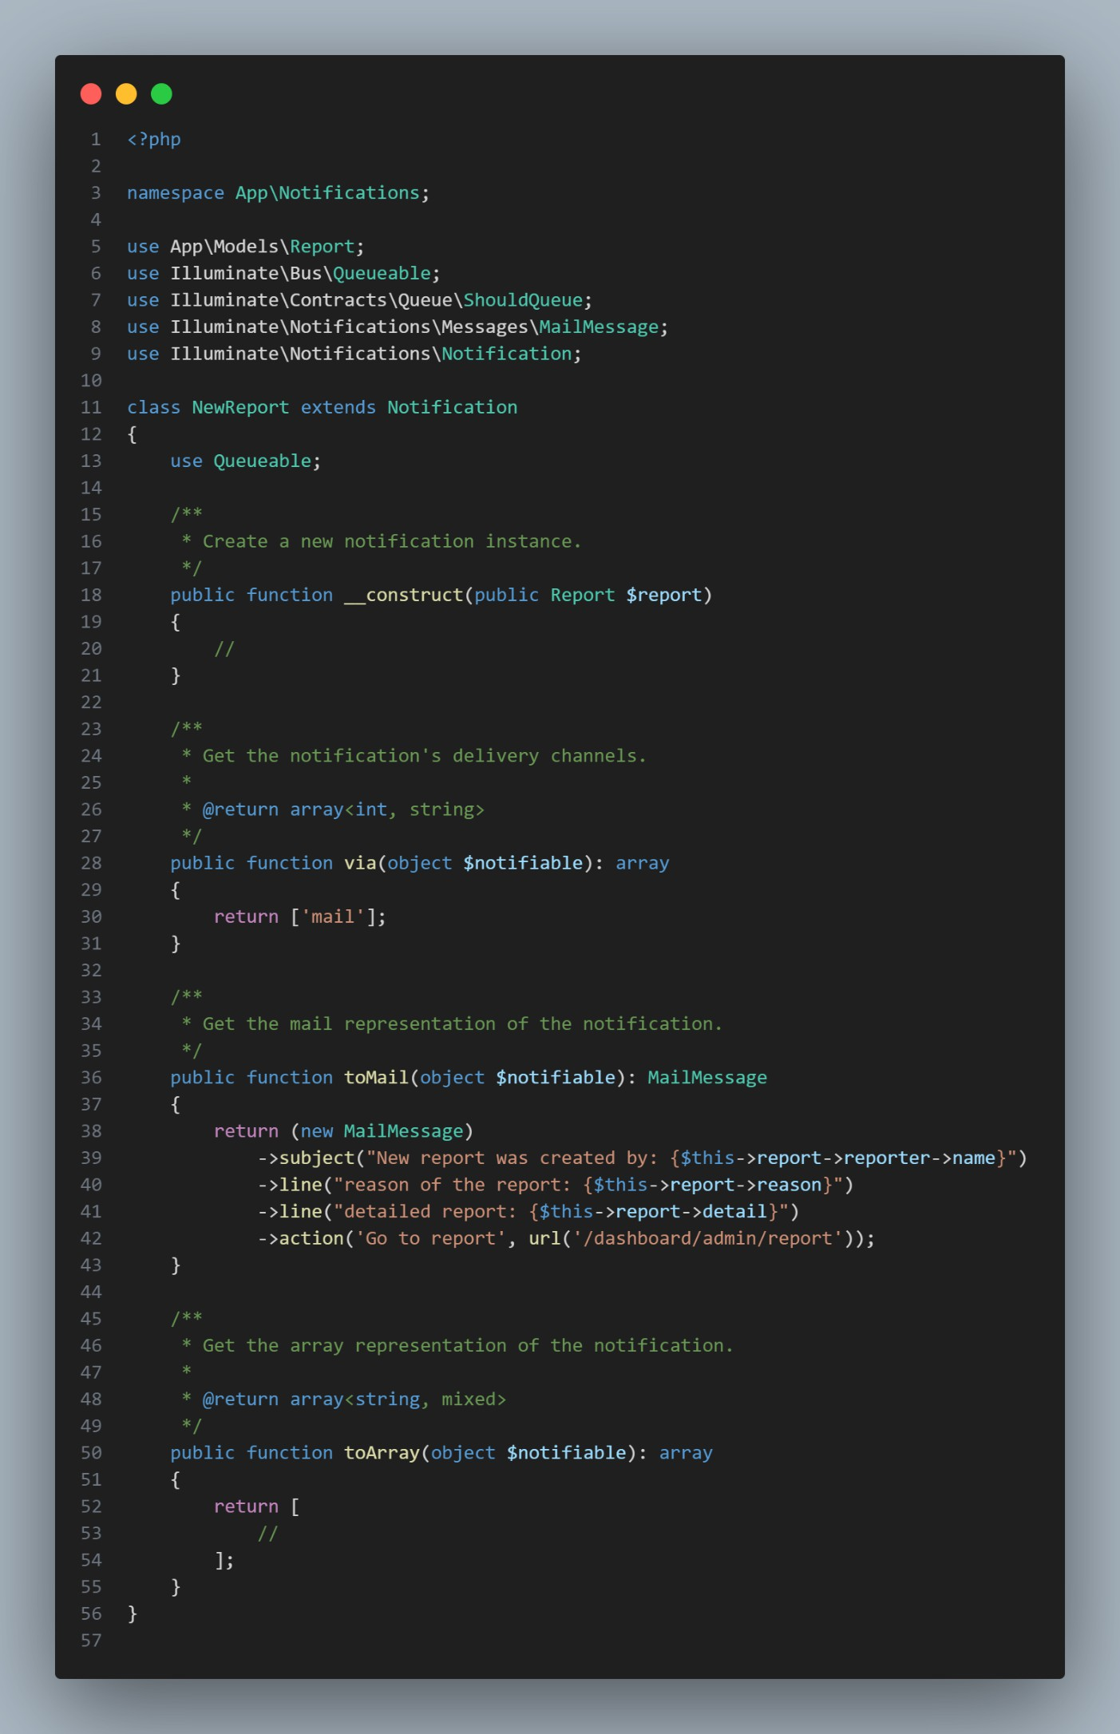

1. **Profilecontroller**

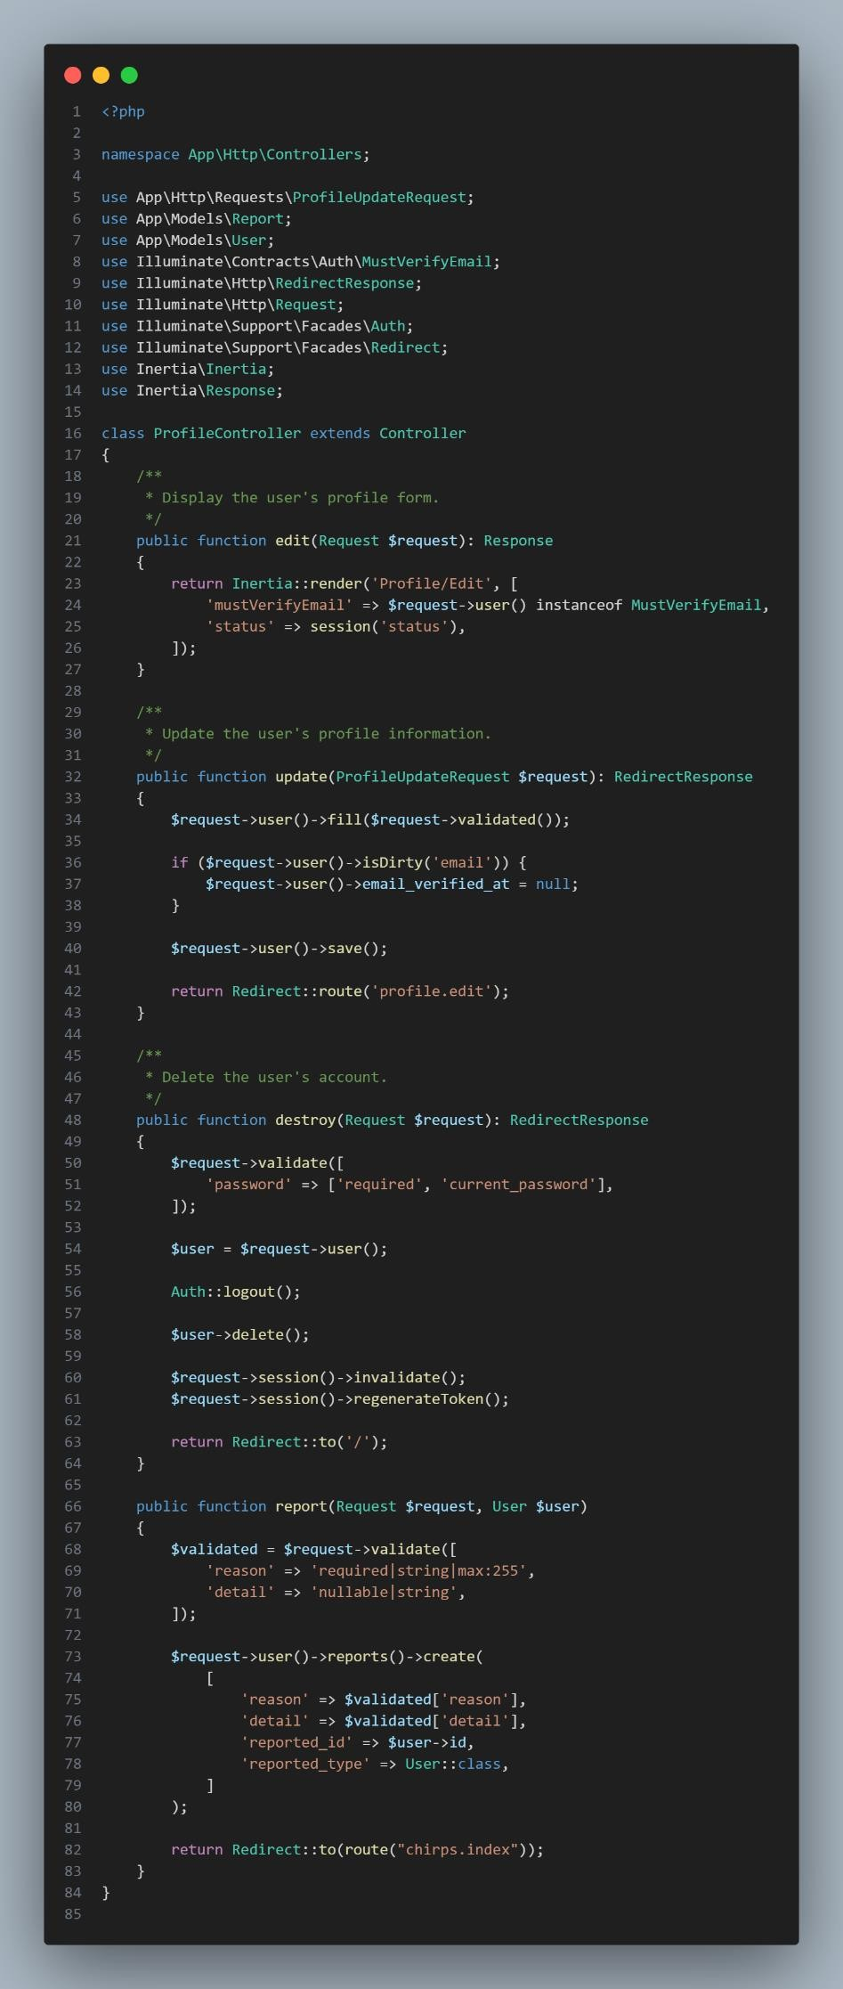

1. **ProfileUpdateRequest**

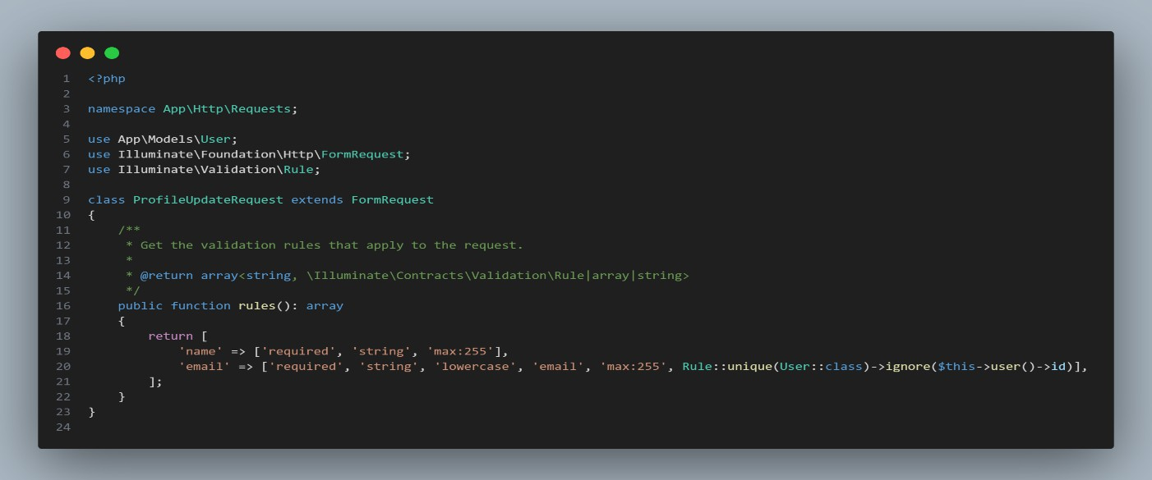

1. **ReactAuteticationLayout**

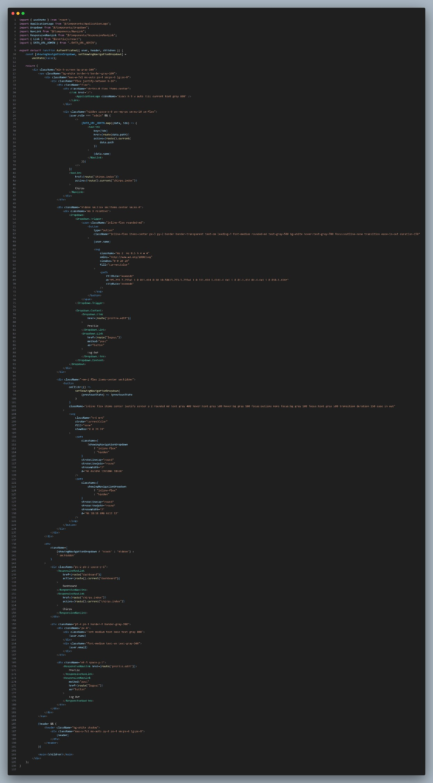

1. **ReactChirpAdmin**

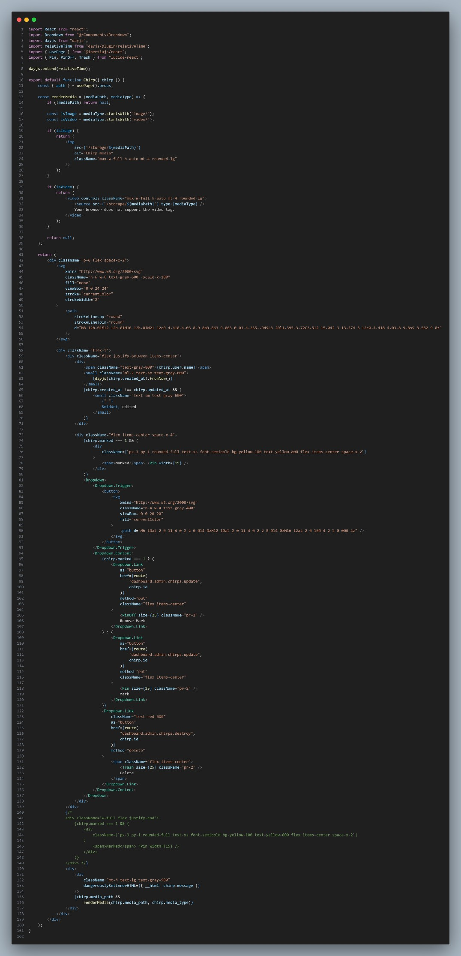

1. **ReactChirpsIndex**

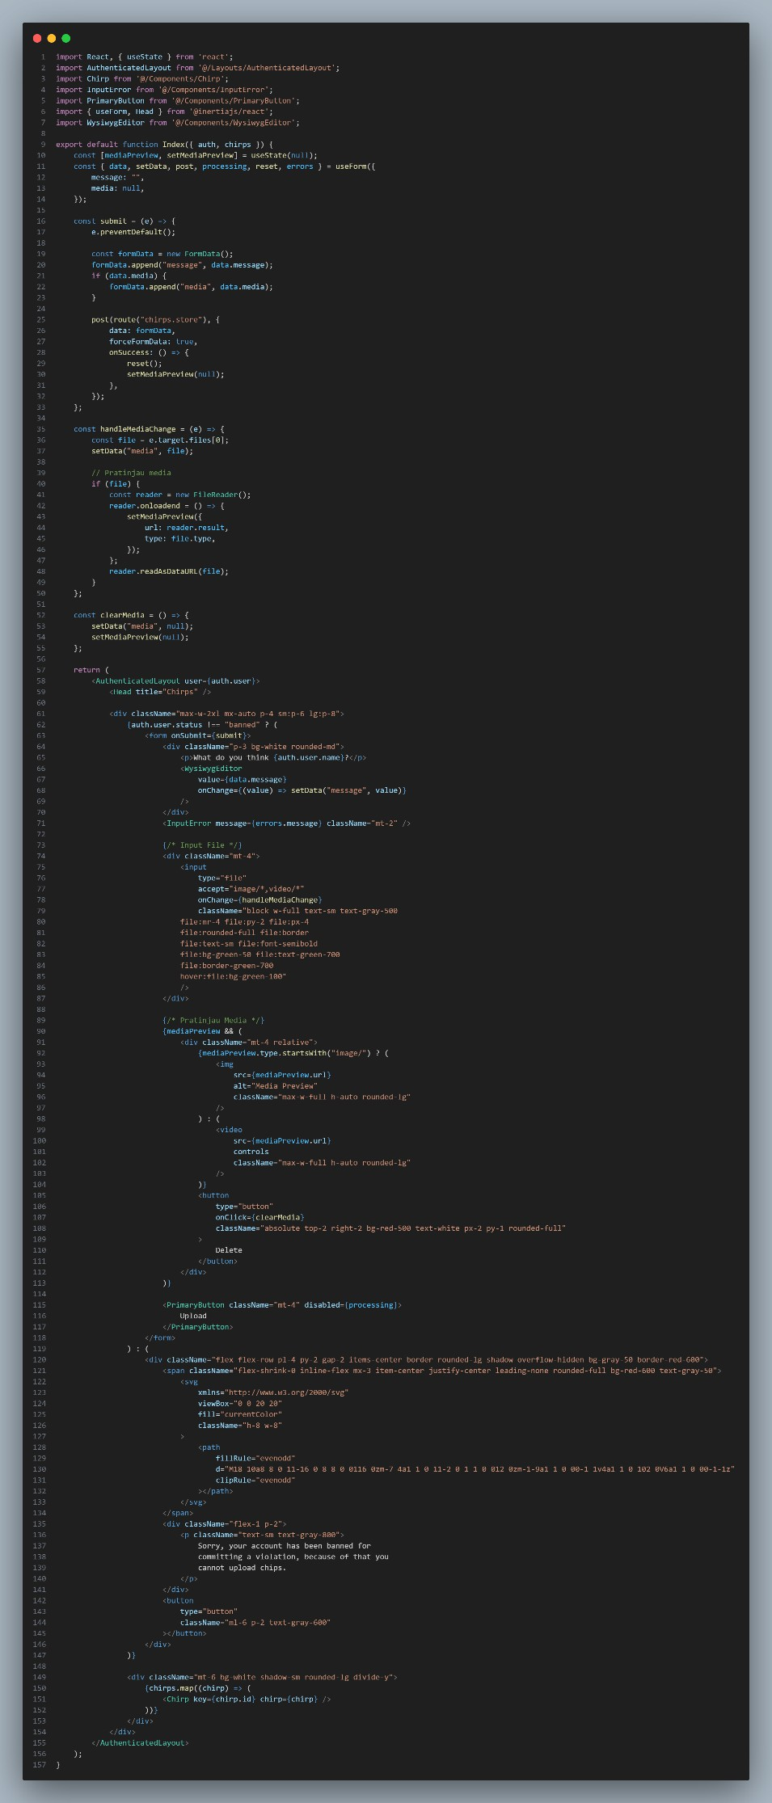

1. **ReactComponentChirps**

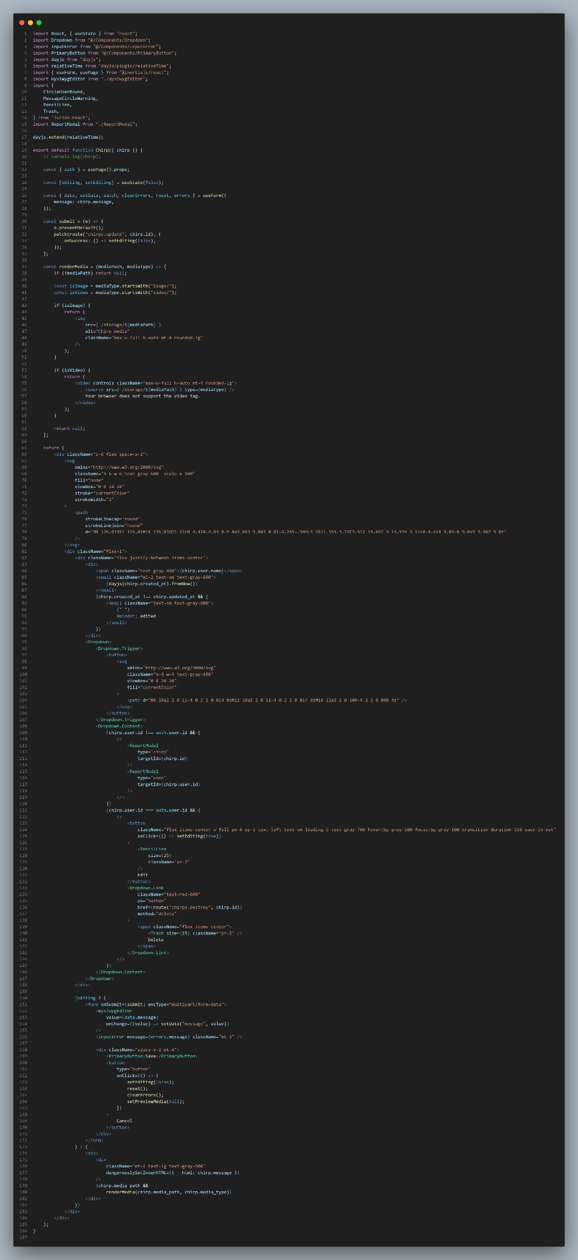

1. **ReactdeleteUserForm**

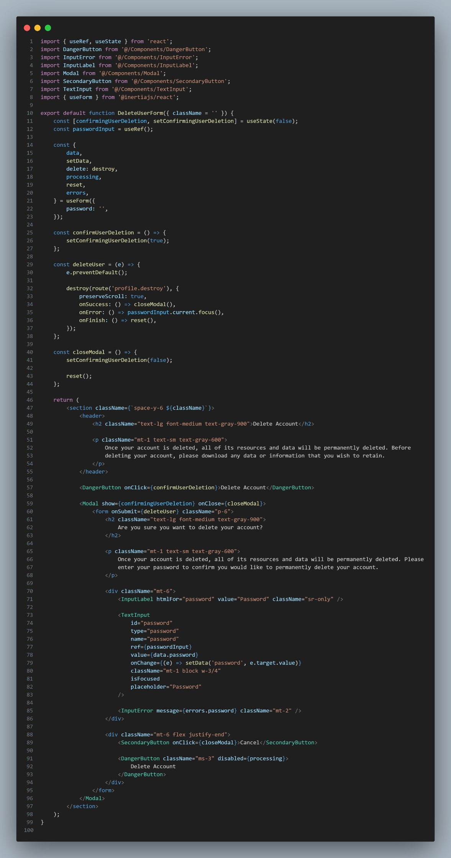

1. **React Login**

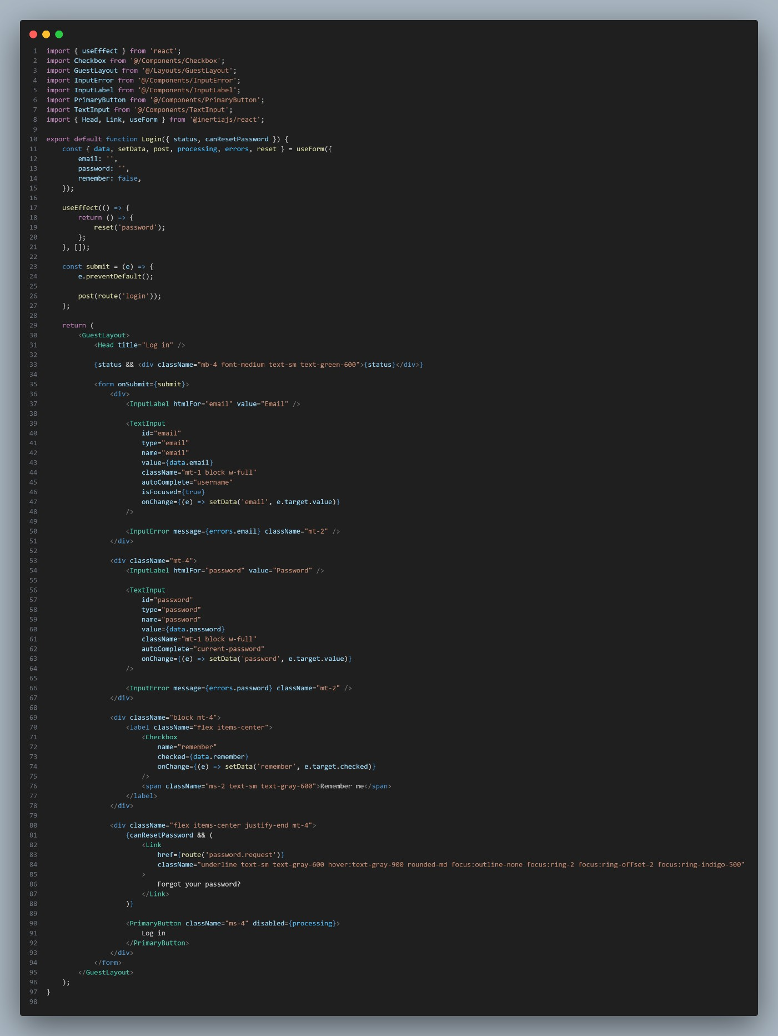

1. **React Register**

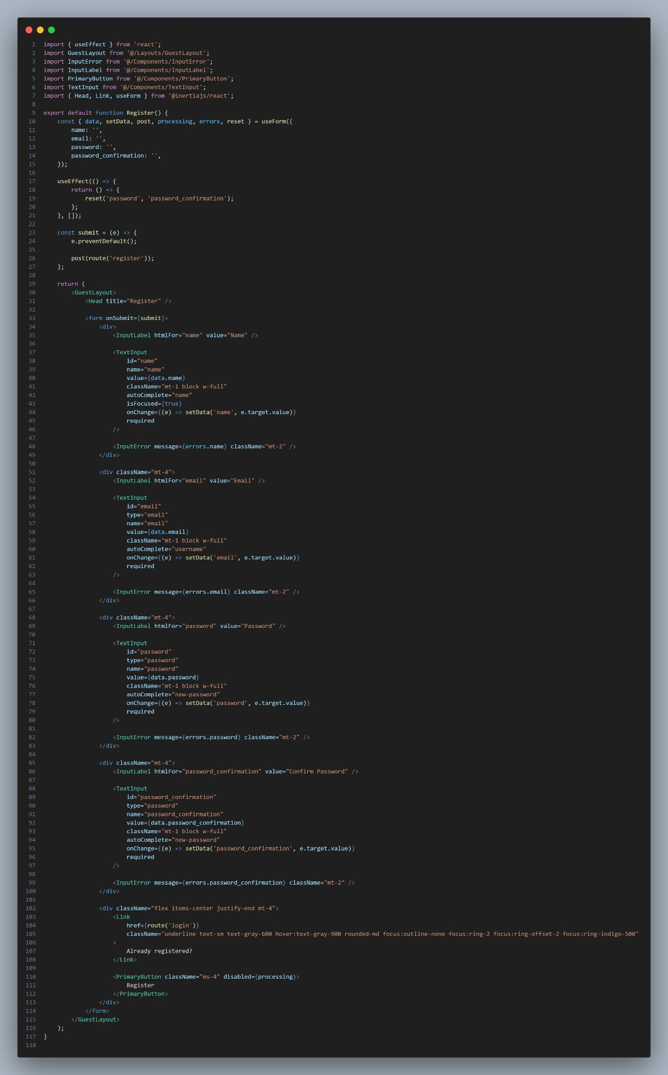

1. **ReactUpdatePasswordForm**

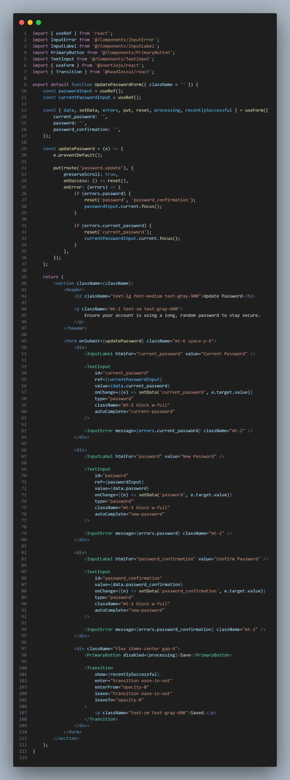

1. **ReactUpdateProfileForm**

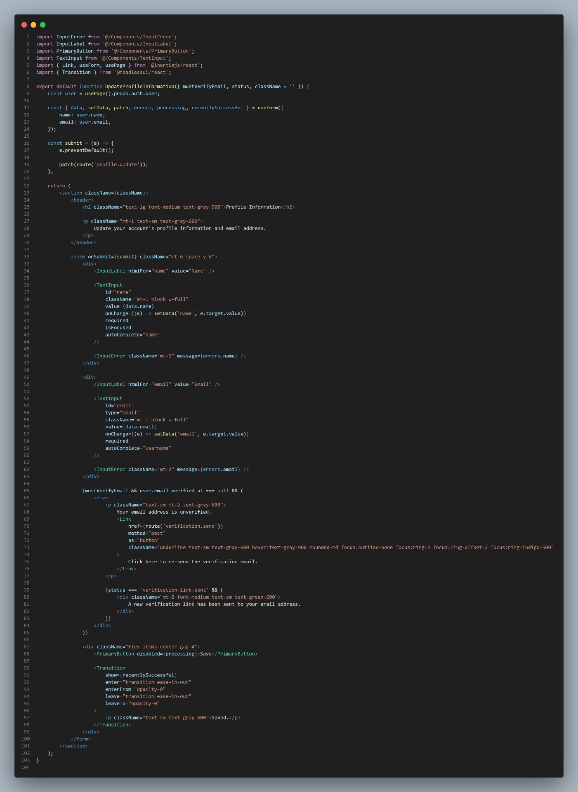

1. **ReportAccount**

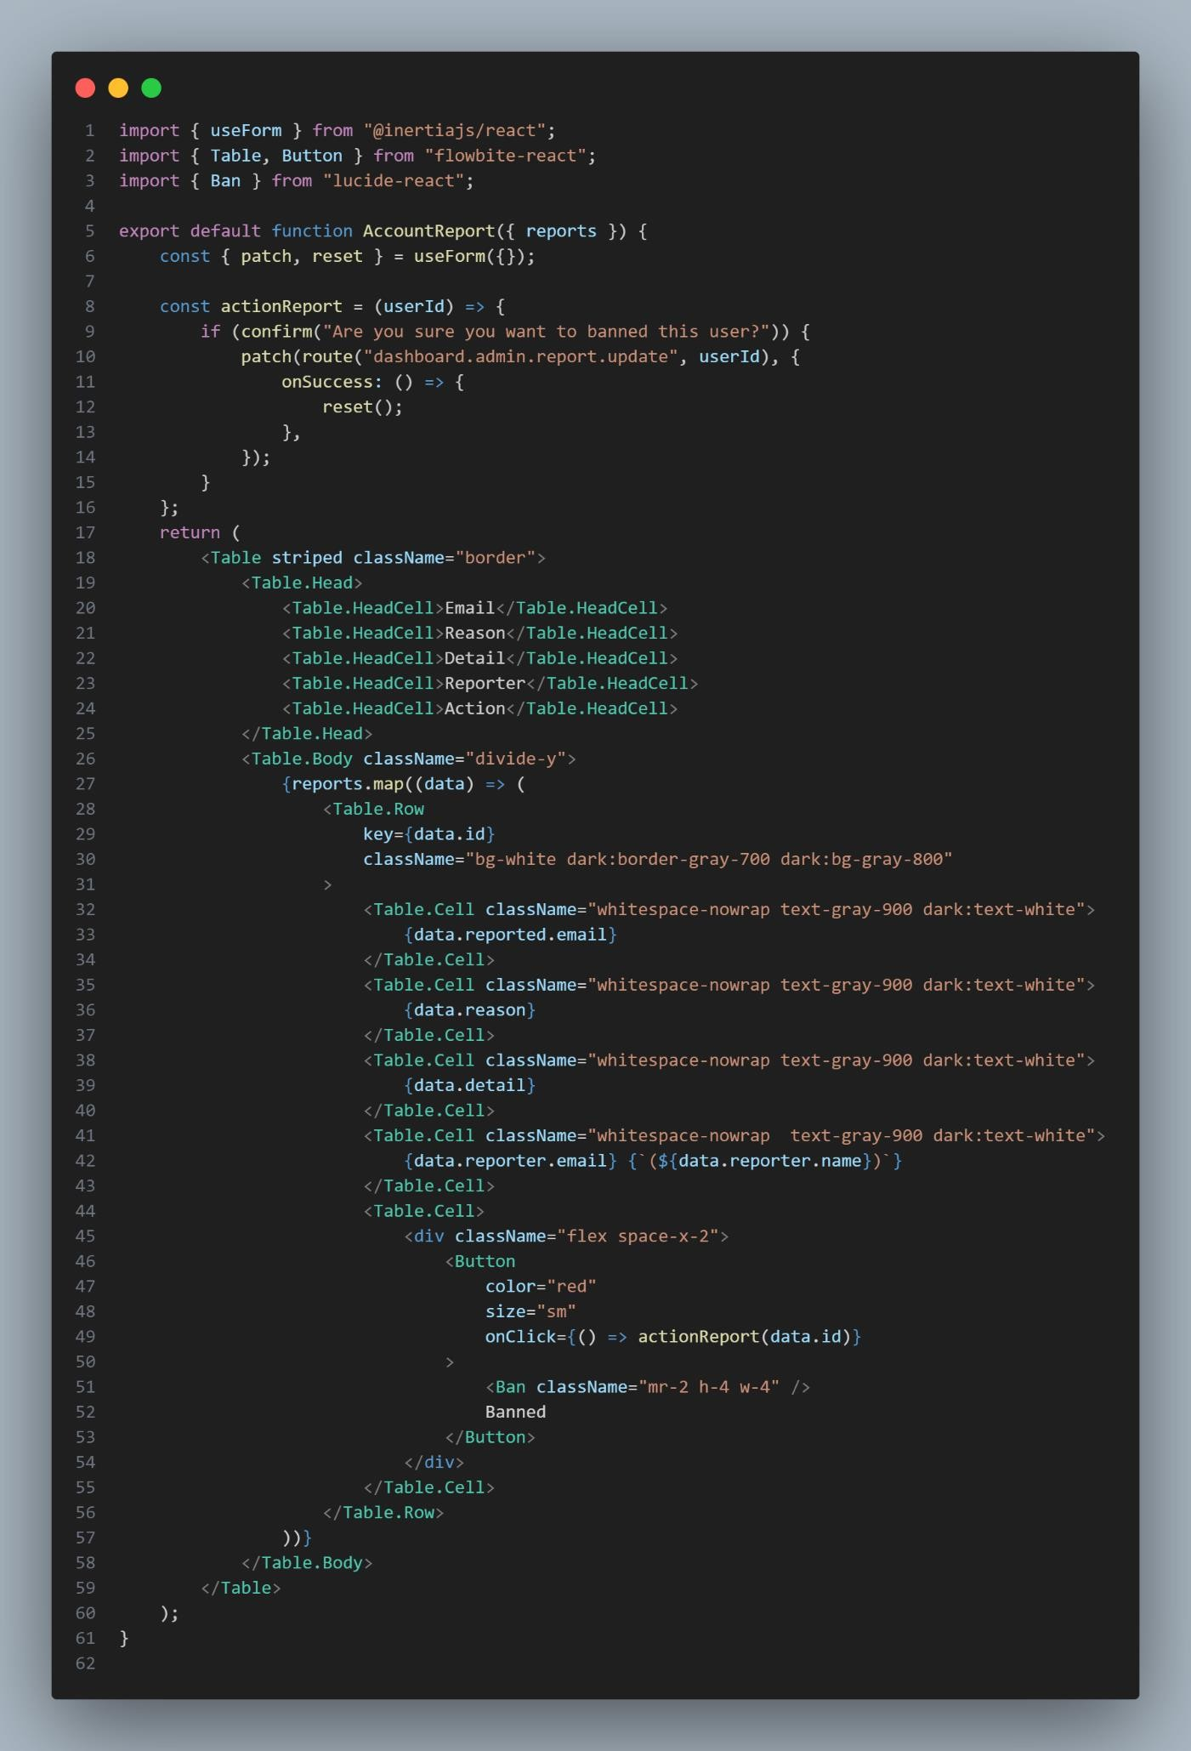

1. **ReportChirps**

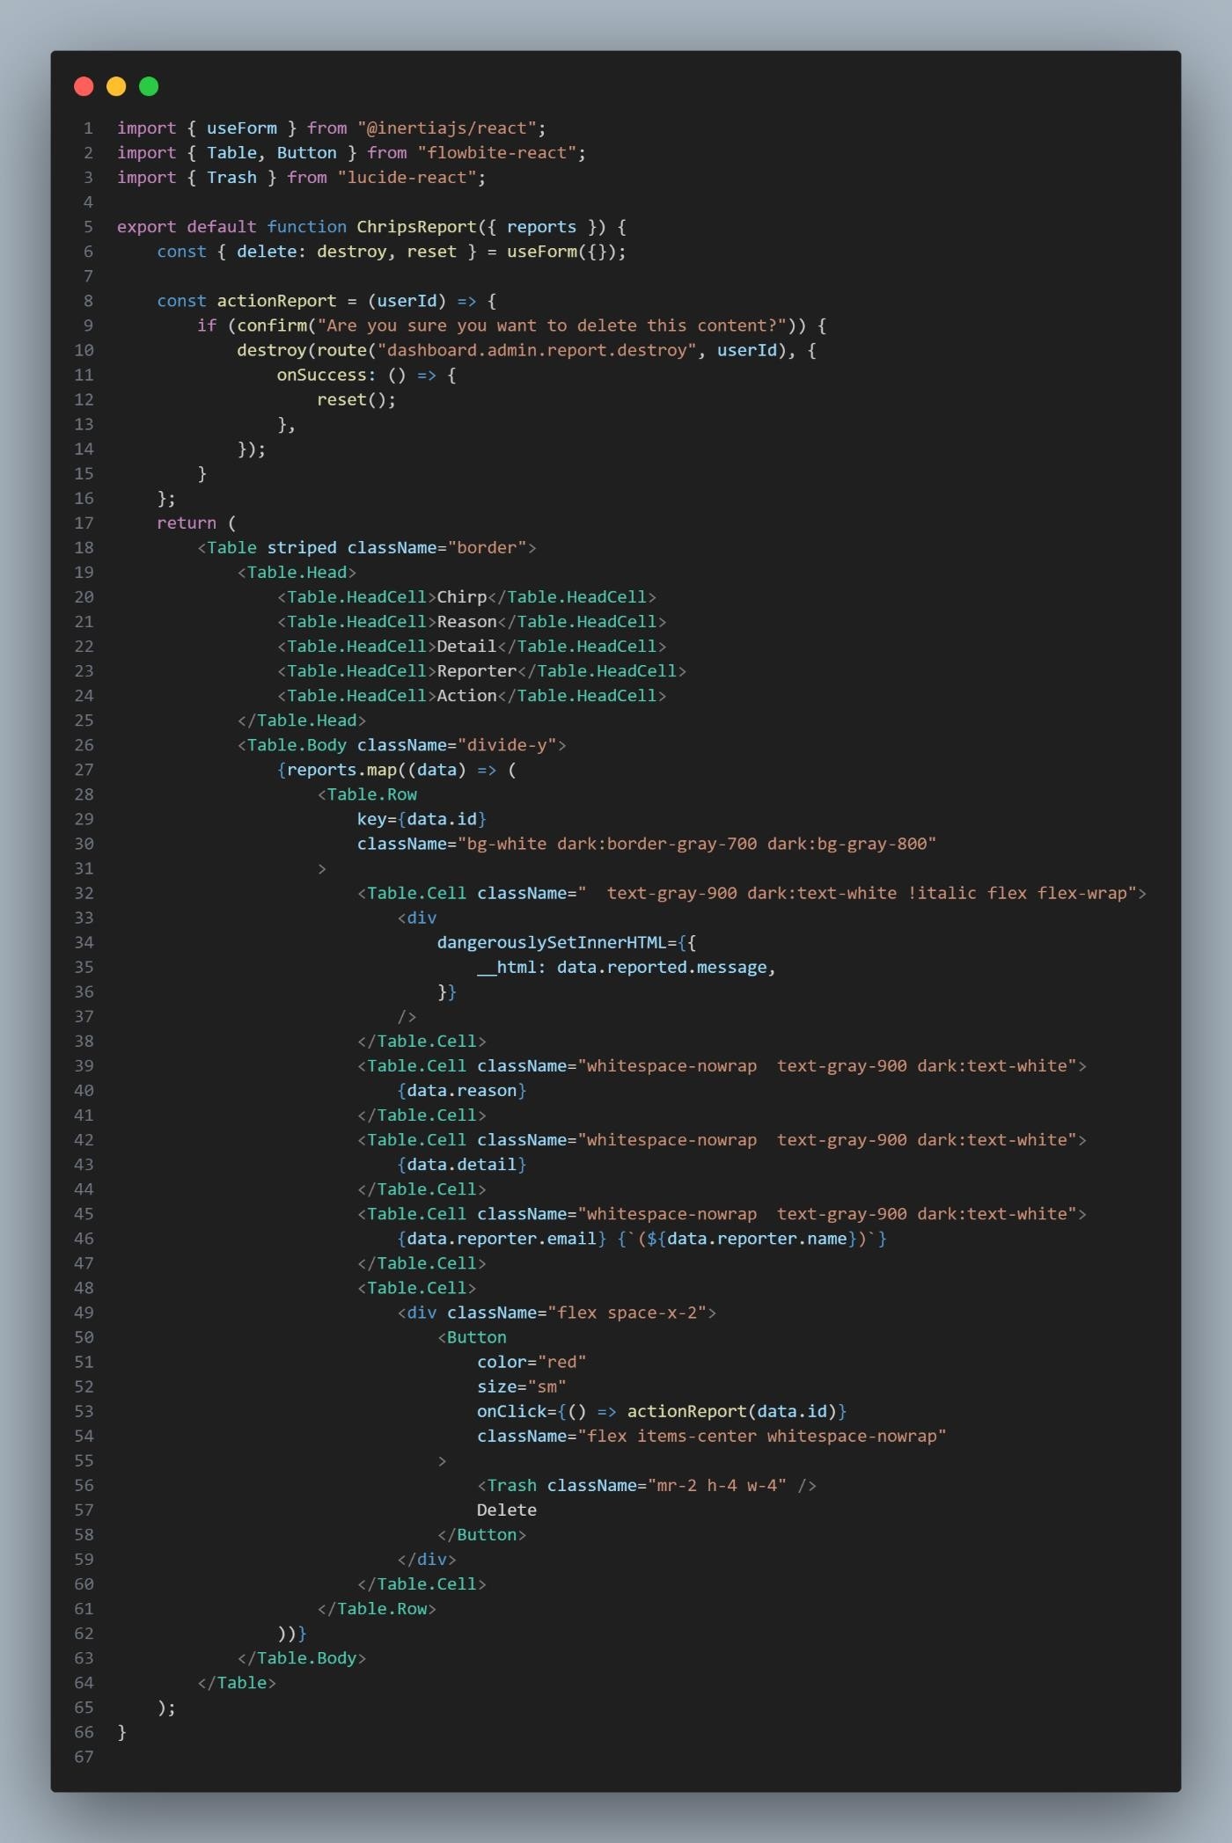

1. **ReportIndex**

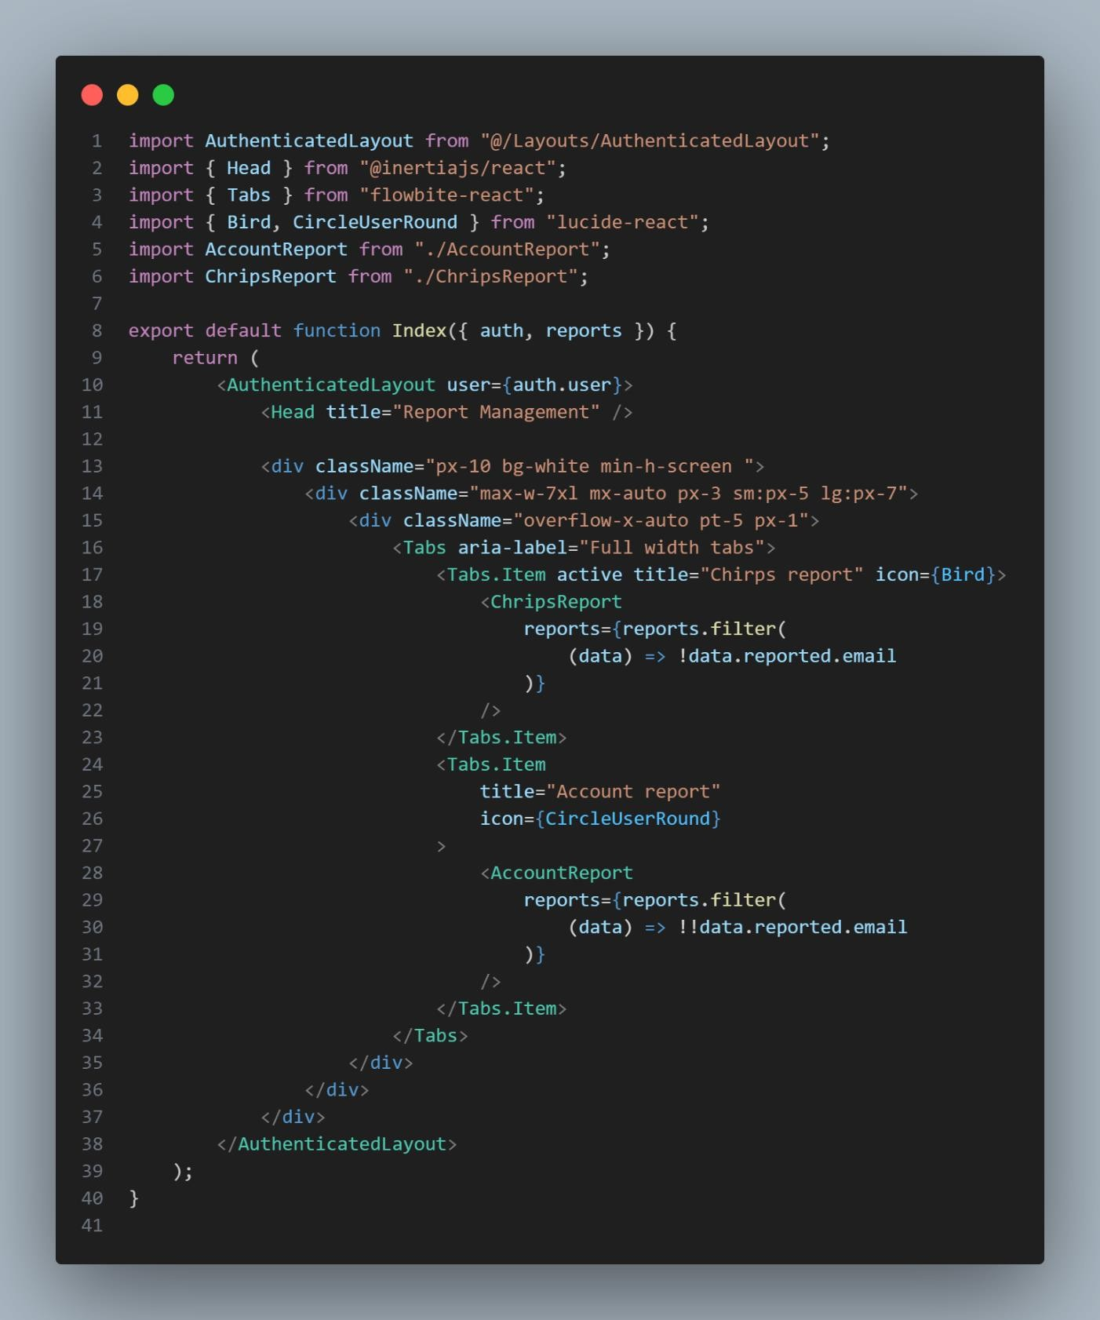

1. **ReportManagementcontroller**

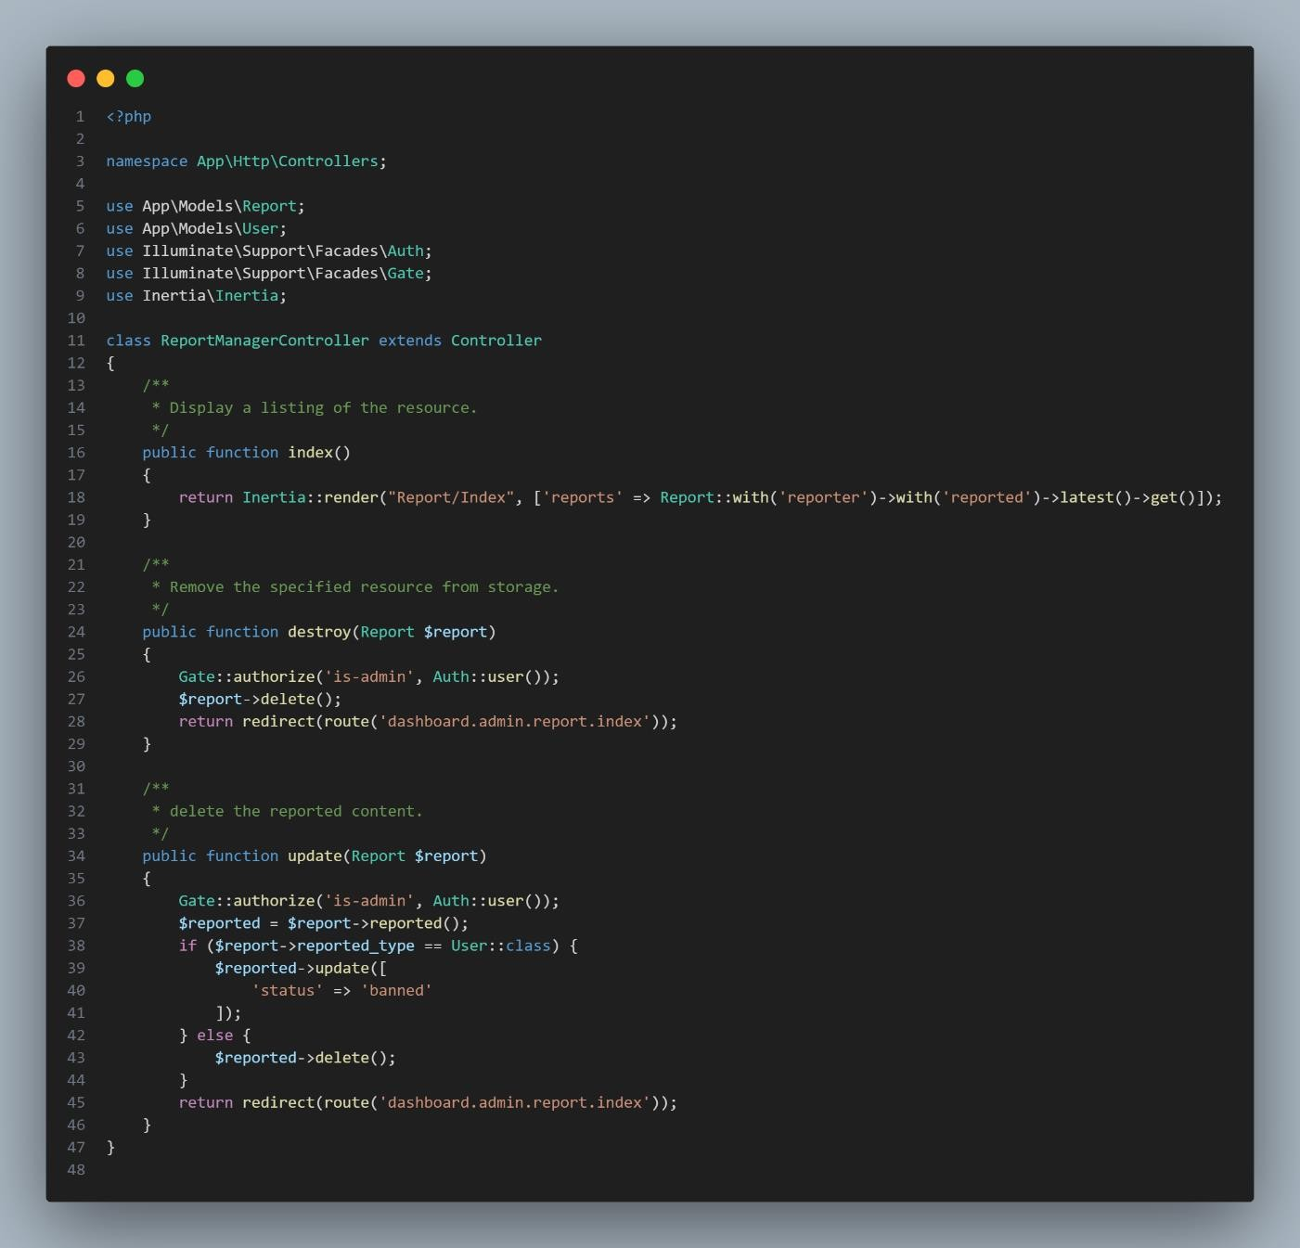

1. **RoutesAuthPhp**

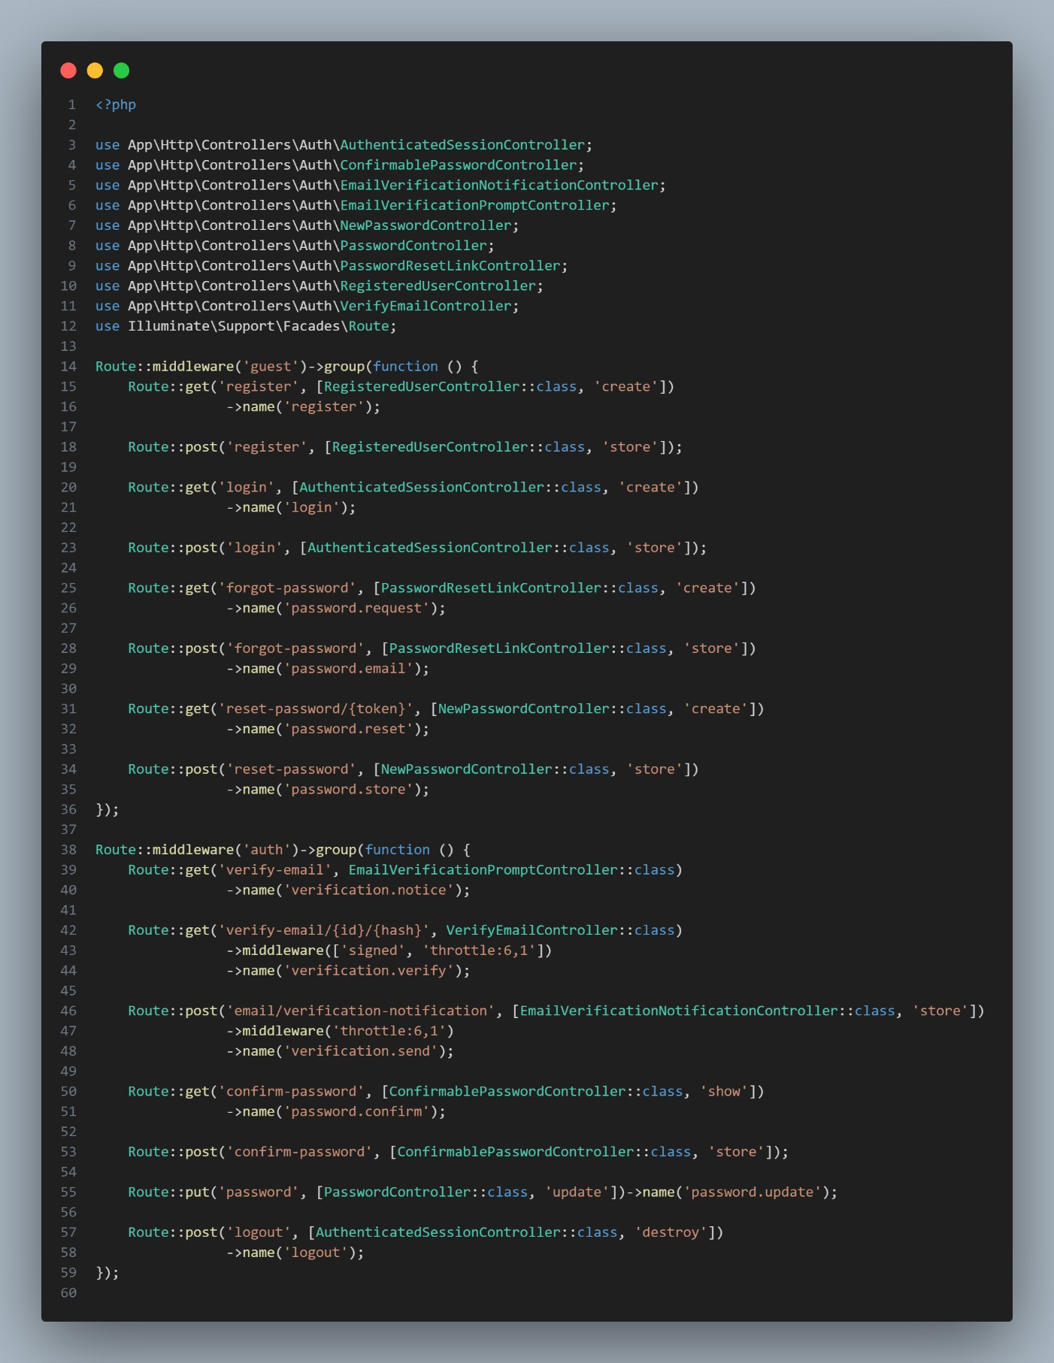

1. **SeederDatabase**

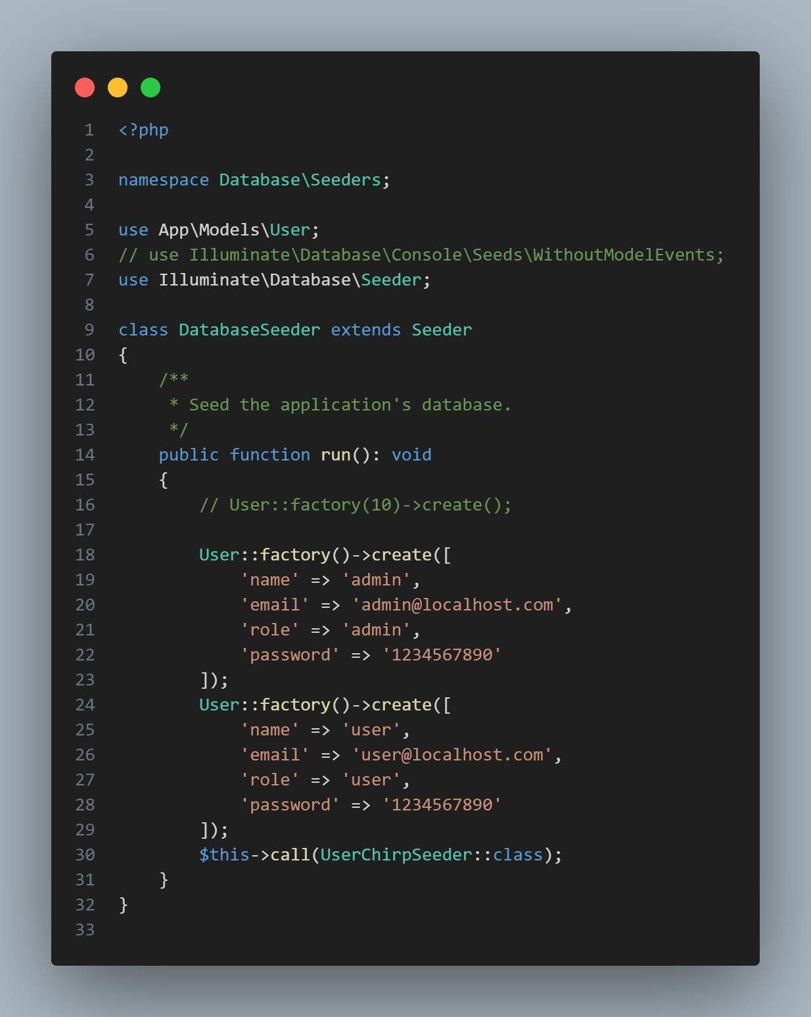

1. **SeedeUserChirps**

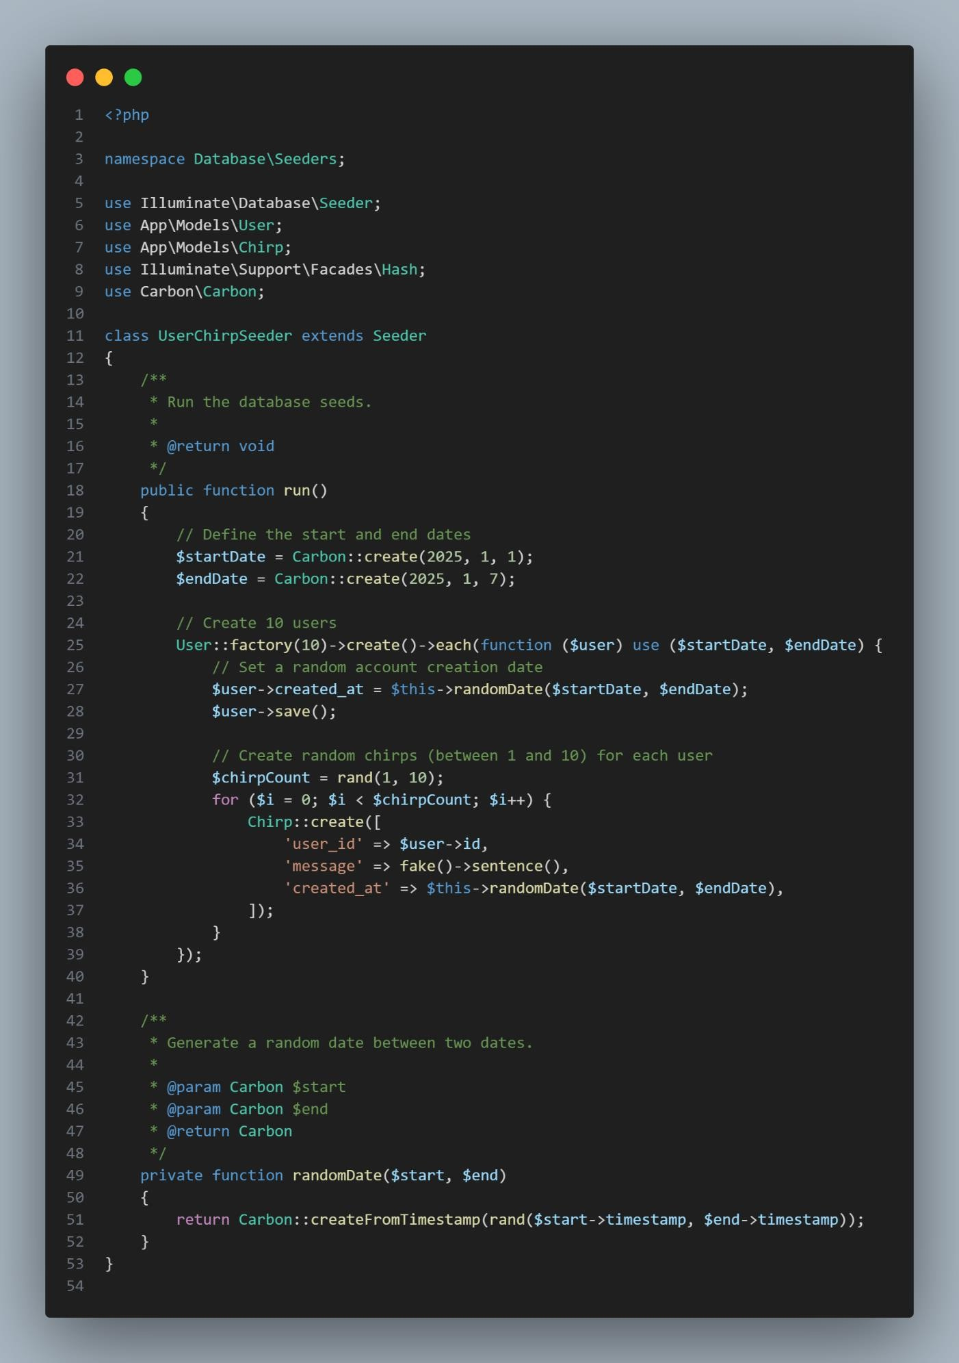

1. **sendChirperCreatedNitifikation**

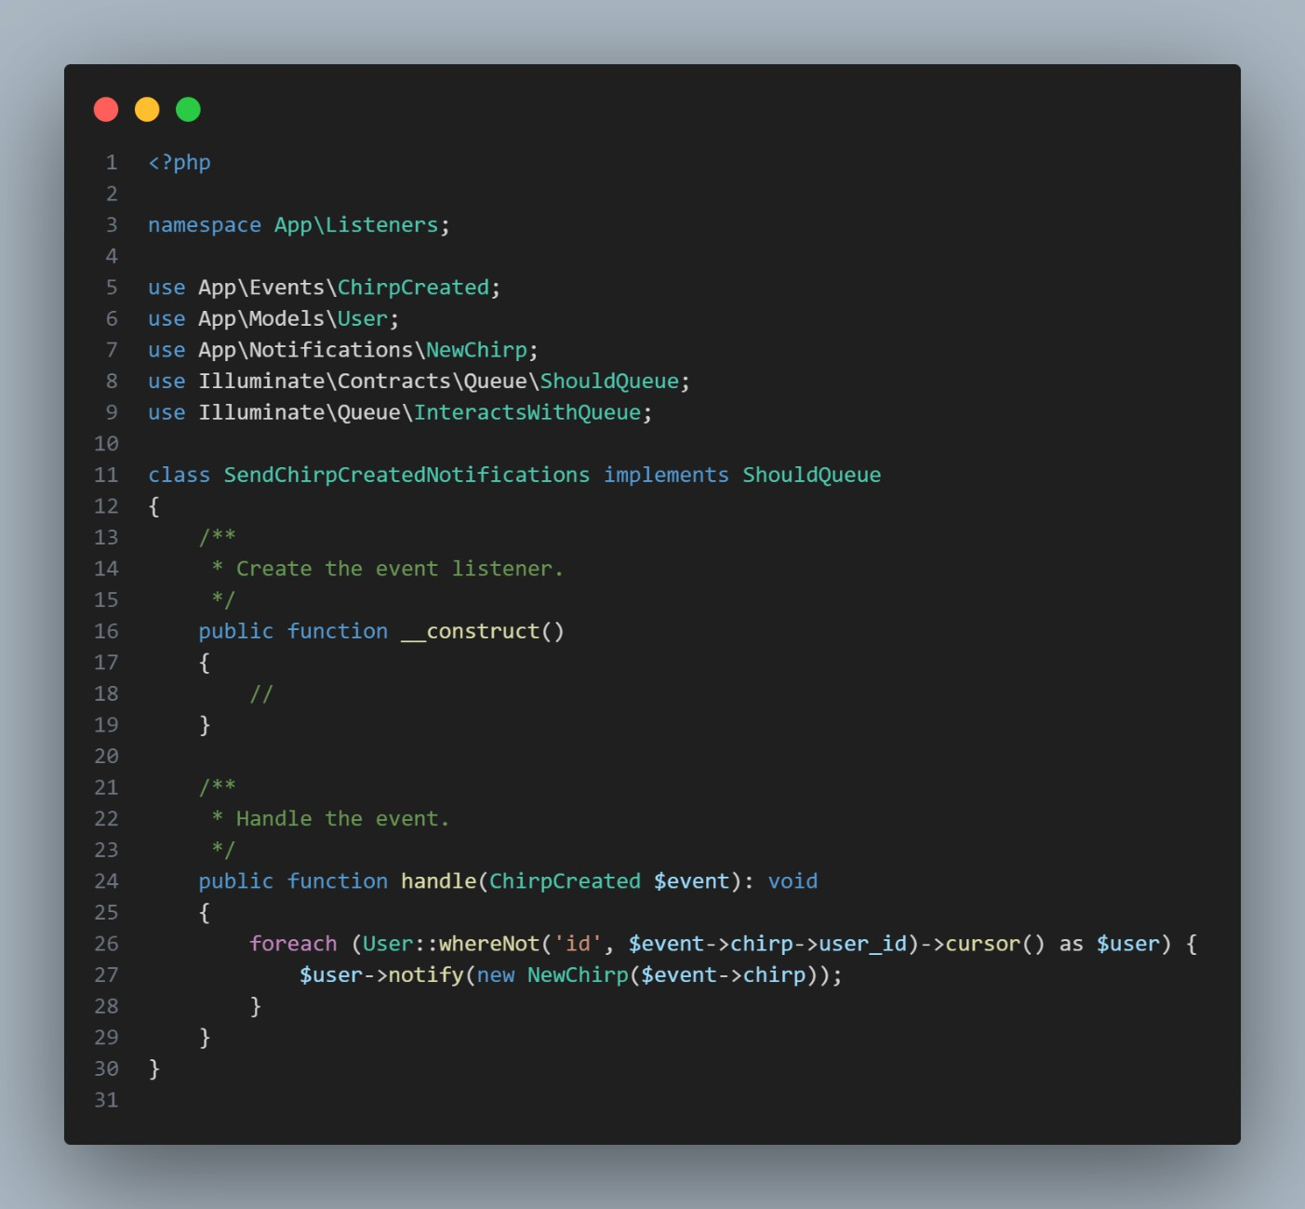

1. **sendReportAdmin**

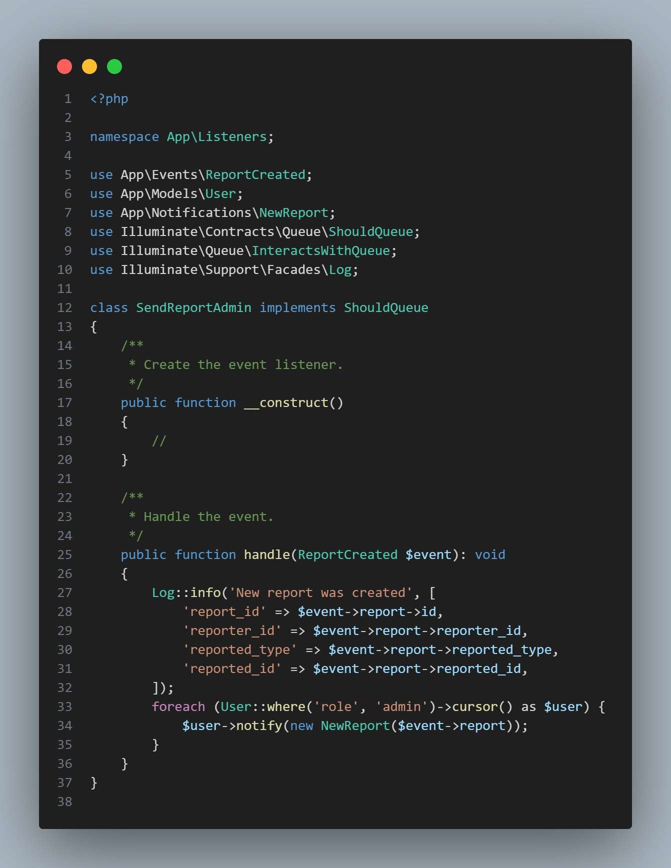

1. 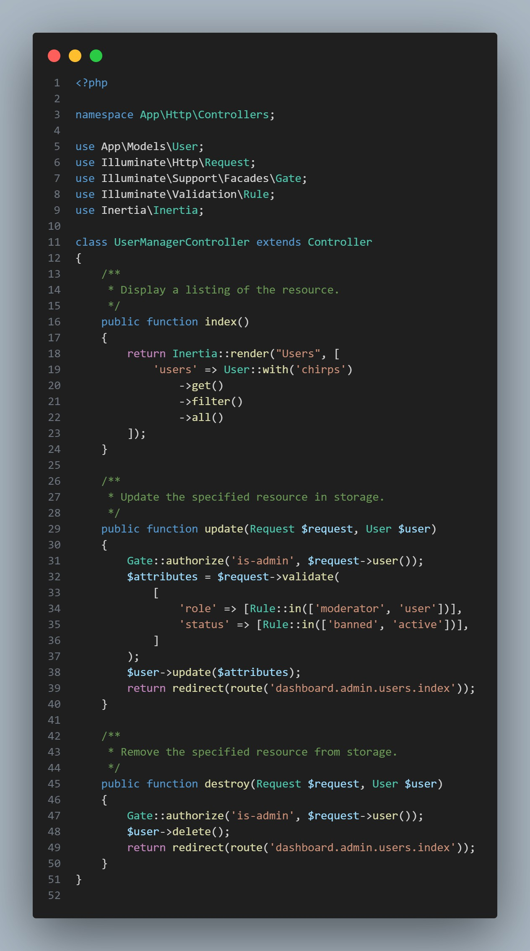**UserManagementcontroller**
2. **UserReact**

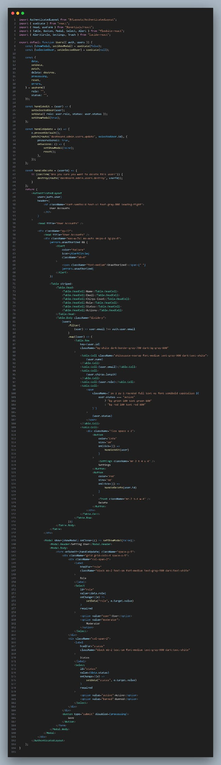

1. 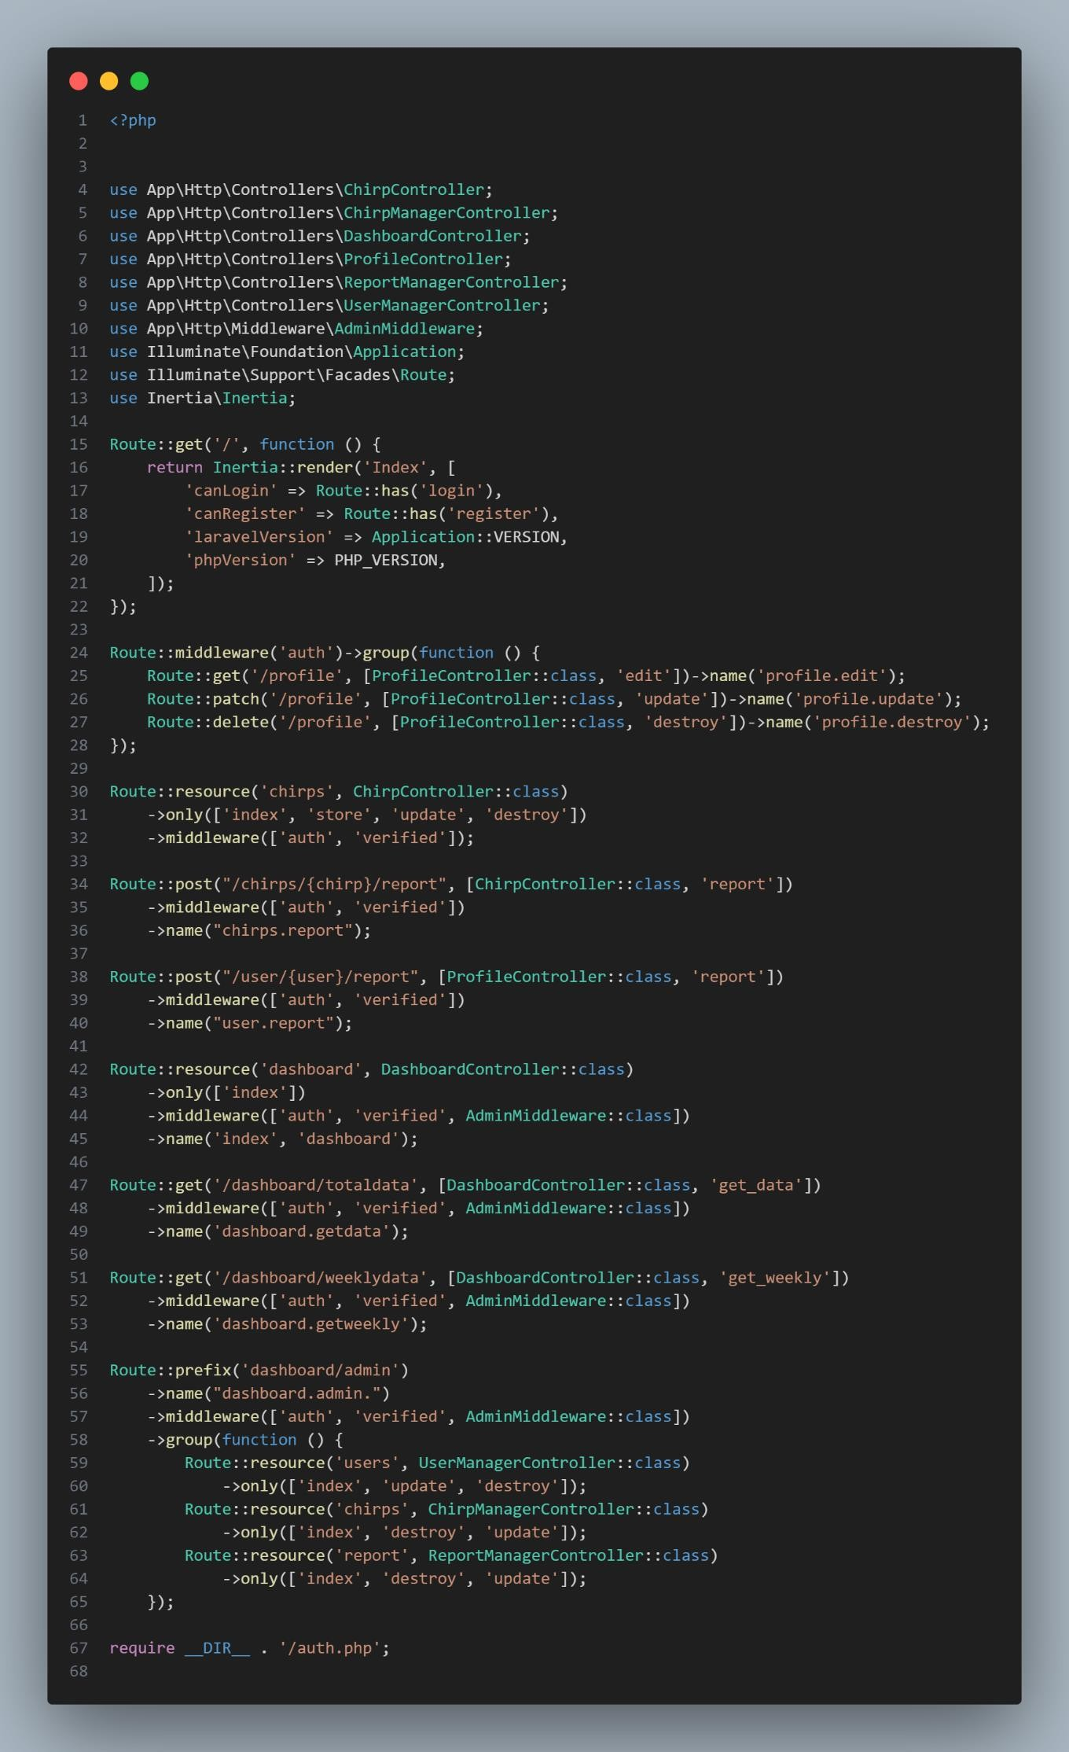**webPhp**

# Dokumentasi Hasil (Output)

1. **Dashboard User**

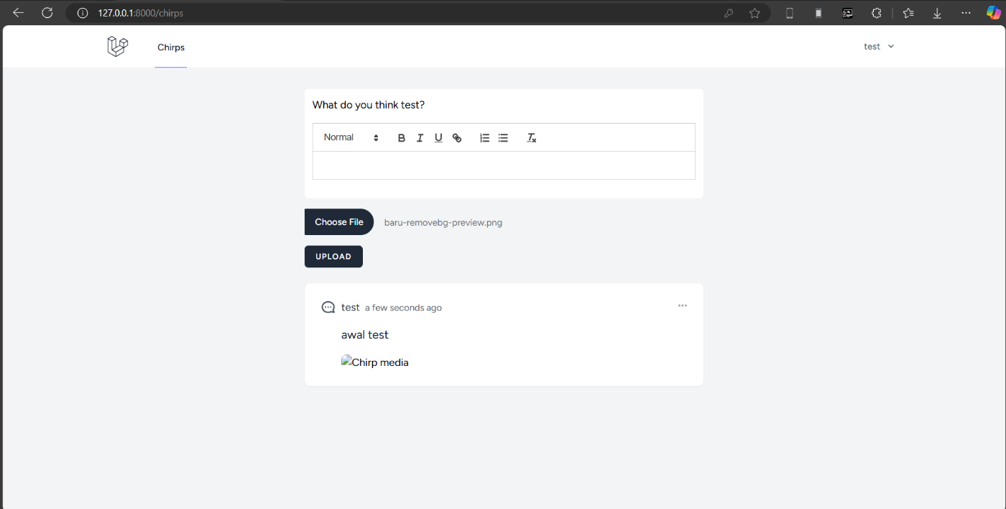

1. **Dashboard Admin**

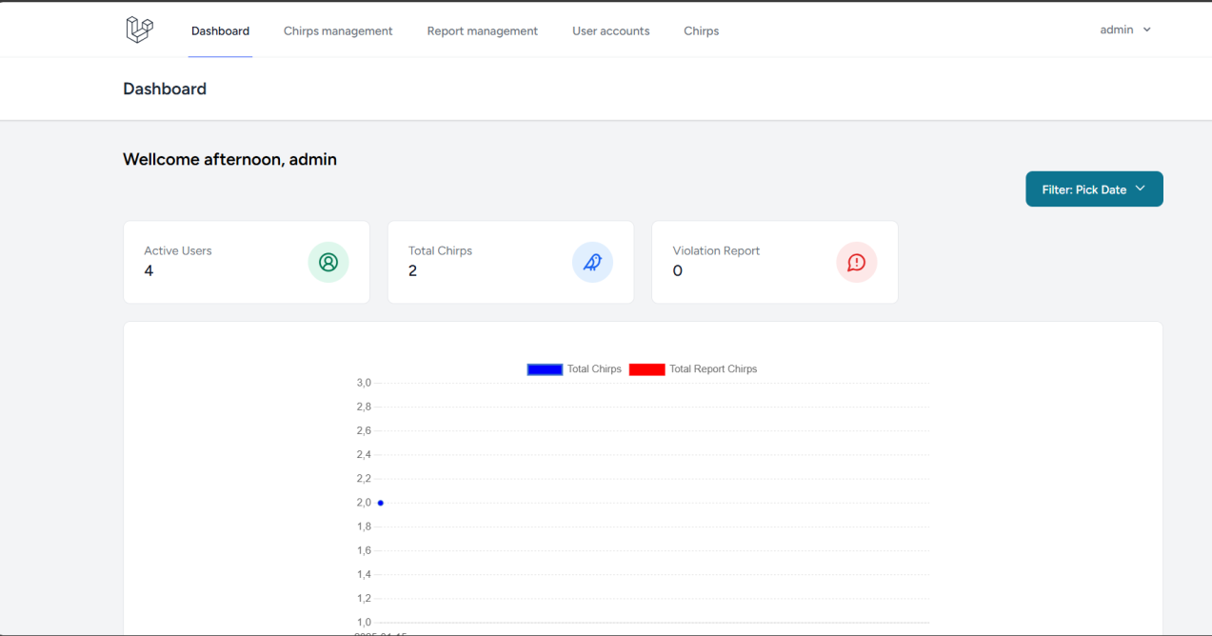

1. **ChirpsMnagement**

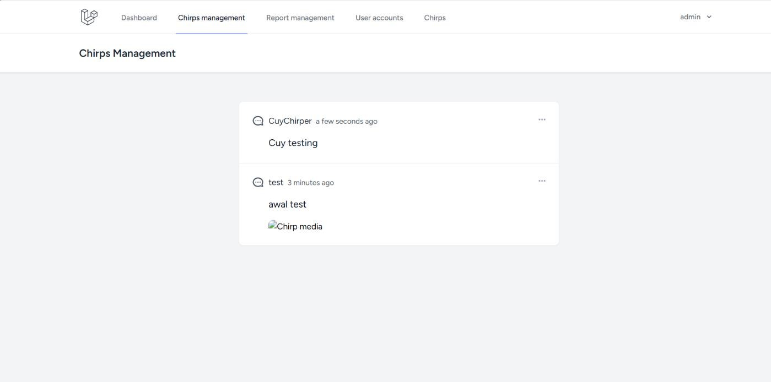

1. **ReportManagement**

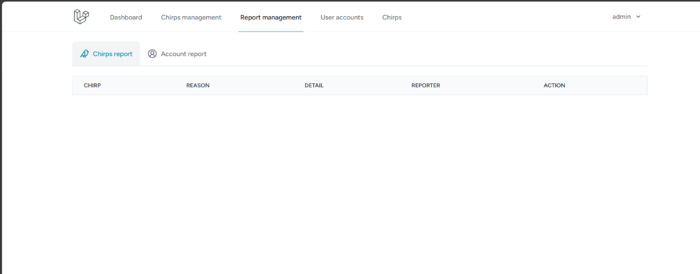

1. **chirpAdmin**

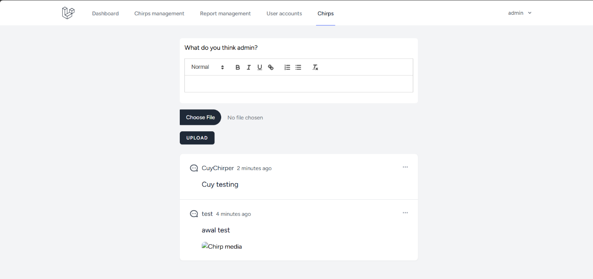

1. **UserAccount**

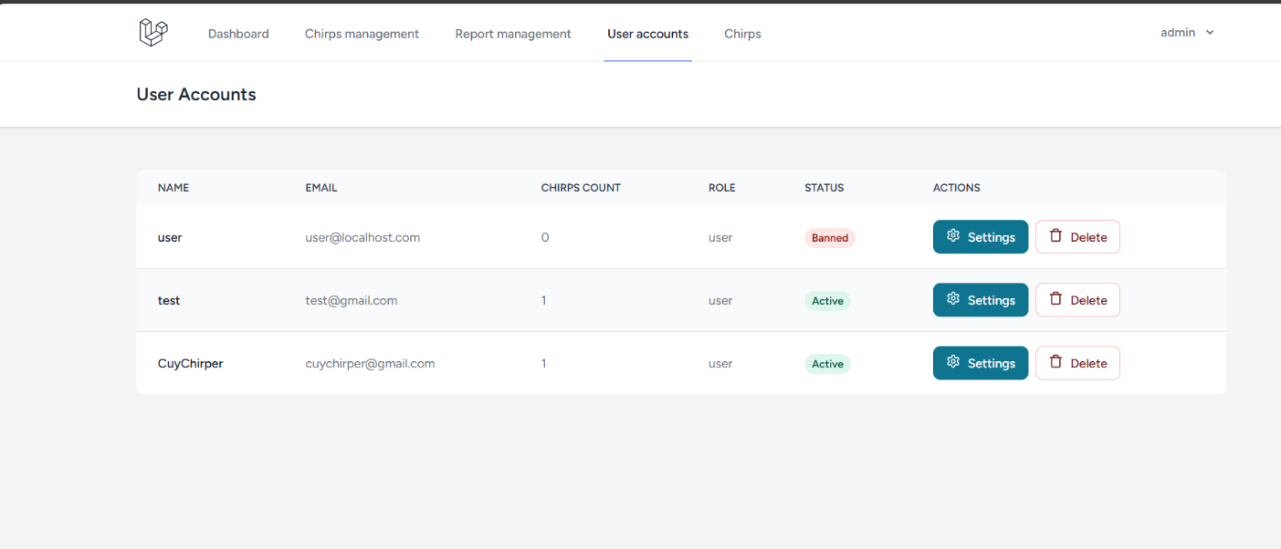

**TERIMAKASIH**